**Project Report**

**On**

**“Movie Booking System”**

**In partial fulfillment for the award of the degree**

**Of**

**BACHELOR OF COMPUTER APPLICATION**

**[B.C.A]**

**Year 2022-2023**

**SUBMITTED BY: GUIDED BY:**

ABC Asst. Prof. ___

PQR

XYZ

**BCA-6th SEMESTER**

**Submitted to:**

**“ College Name ”**

Affiliated to

**Veer Narmad South Gujarat University**

**INDEX**

|  |  |  |
| --- | --- | --- |
| **SR.NO** | **PARTICULAR** | **PG.NO** |
| **1** | **Introduction** |  |
|  | 1.1 About Movie Ticket Booking System |  |
|  | 1.2 Problem Observation |  |
|  | 1.3 Pros and Cons |  |
|  | 1.4 Project Overview |  |
| **2** | **System Environment** |  |
|  | 2.1 Hardware Specification |  |
|  | 2.2 Software Specification |  |
| **3** | **Problem Specification** |  |
|  | 3.1 Introduction, Objective and Purpose |  |
|  | 3.2 System Model |  |
|  | 3.3 Feasibility Study |  |
|  | 3.3.1 Economic Feasibility |  |
|  | 3.3.2 Technical Feasibility |  |
|  | 3.3.3 Behavioral Feasibility |  |
| **4** | **Risk Identification and Management** |  |
|  | 4.1 Risk Monitoring |  |
| **5** | **Technology Used for Development** |  |
|  | 5.1 Front-End Tools |  |
|  | 5.2 Back-End Tools |  |
|  | 5.3 Extra Tools |  |
| **6** | **Planning** |  |
|  | 6.1 System Planning |  |
|  | 6.2 Time Line Chart |  |
| **7** | **System Analysis** |  |
|  | 7.1 Database Design |  |
|  | 7.2 System Flow Chart |  |
|  | 7.3 ER-Diagram |  |
|  | 7.4 Data Flow Diagram |  |
|  | 7.5 Data Dictionary |  |
| **8** | **Designing** |  |
|  | 8.1 Admin Panel |  |
|  | 8.2 User Panel |  |
| **9** | **Testing** |  |
|  | 9.1 Software Testing |  |
|  | 9.2 Unit Testing |  |
|  | 9.3 System Testing |  |
|  | 9.4 Test Cases |  |
| **10** | **Limitation and System Enhancement** |  |
|  | 10.1 Limitations |  |
|  | 10.2 System Enhancement |  |
| **11** | **References** |  |
|  | 11.1 References |  |

**ACKNOWLEDGEMENT**

Team Effort is only key to success. Success cannot be achieved single-handed. So, we would like to express our sincere thanks to all the dignitaries who were involved in making this project a great joy and turning it into successful piece of work.

We would like to take opportunity to thank my college **“ College Name ”** for giving us this tremendous opportunity to work in the real-time project.

**Prof. ___**, our professor and project coordinator, has been very prudent to us throughout our college studies. He is the person who has been giving direction to our work and the shape to our imagination. We express our regards to her from the core of our heart.

We also like to thank our **H.O.D. Prof. ___** and all the professors who are always ready to give best guidance. They are the individuals who give solutions whenever required. We would also like to acknowledge all our friends and colleagues, team members for their help and encouragement from time to time. The constant support and encouragement of my friend deeply appreciates. The project indeed gave challenging and exhilarating experience in designing and developing the required system.

Finally, we would like to thank our parents for their support throughout the project. We owe a special debt to our family & friends for their supports blessing and encouragement for us.

Yours Sincerely,

ABC

PQR

XYZ

1. **Introduction**



**1.1 About Movie Ticket Booking System**

Movie Ticket Booking System is a place where user can book movie ticket of his/her favourite movie and admin can add latest movies show in the available theatres and screens.

**Team goals and objective**

* The main goal of our team is to build a web application that can provide user a facility to book latest movies at ease of comfort without any inconvenience.

**Project Team**

* ABC
* PQR
* XYZ

**Project Guide**

* Prof. ___

**1.2 Problem Observation**

We have discovered user’s problem by researching on their interests and we have found that most of the people visit different theatres to book movie tickets by waiting a long queue. We have found that user wants to book tickets without waiting on a long queue and also as early as possible. So, we have decided to make things easier for user by making this movie booking website where user can book ticket without waiting in queue.

**1.3 Pros and Cons**

**Advantages:**

* Provide facility for movie ticket booking
* Advance booking from anytime and anywhere
* Early Booking

**Disadvantages:**

* Internet handling charges

**1.4 Project Overview**

|  |  |
| --- | --- |
| **Project Title** | Movie Ticket Booking System |
| **Project Category** | Online Booking System |
| **Project Duration** | 3 months |
| **Front End** | PHP  HTML5  CSS3  JavaScript |
| **Back End** | MySQL |
| **Browser** | Google Chrome  Microsoft Edge |
| **Development Tools** | Visual Studio Code |
| **Documentation Tools** | Microsoft Office Word 2021 |
| **Developers** | ABC  PQR  XYZ |

**2. System Environment**



**2.1 Hardware Specification**

Processor : 11th Gen intel i5-11300H

RAM : 8 GB or above

Hard Disk : 1 TB or above

Input Devices : Keyboard, Mouse

Output Devices : Monitor

Required : Internet connection

**2.2 Software Specification**

Operating System : Windows 11

Front-end : PHP-LARAVEL

Back-end : MySQL

**3. Problem Specification**



**3.1 Introduction, Objective and Purpose**

**Introduction:**

This project is fully facilitated with the real-world movie ticket booking system of the seats with the approach of the multi-screen and many to one as well as on to many approaches to the movies and screen.

There are two Major Section of Movie Ticket Booking System:

✓ Admin Section

✓ User Section

This project provides complete facility for Admin and User. Project is built in such a way that the user can book movie tickets from any multiplex without any inconvenience. In online movie ticket booking system the user can book tickets of any movie simply by selecting the seat which are available in the multiplex and then can pay the price which is automatically generated when the user clicks the seat. One can even cancel his/her tickets after booking them.

This project is without any logical or semantic error with sufficient required validations. Last but not the least, this project is equipped with state of art user interface.

**Objective:**

* Complete Database Management
* Database security
* Effective database management
* Transaction managements
* Maintain addition or deletion in any category
* Web Based System
* Easy and fast response
* Flexible to access
* Provides details efficiently
* Security Management
* Session tracking
* System should be error free
* Modification does not point to error
* System should be user friendly
* User friendly interface. Availability of multiple

**Purpose:**

The main purpose of Online Movie Ticket Booking System Project is to provide an automated system of buying movie ticket. Now user can get to know movie show timing and buy tickets online via internet 24×7. Admin has full control over all modules of this website. Admin can add new movie details and poster. User can view this schedule and book ticket in his desired show time. User should register themselves on the website for buying ticket.

**3.2 System Model**

**Prototype Model...**

**Why we use prototype model?**

Our aim is develop a site which is much friendly for users, so we follow Prototype Model. First we gathering requirement which users rarely want. Then we develop a working model related to the customer requirement & try to implement all the things.

Then we move to Customer evaluation & get the review from Customer, if Customer can Satisfied then it is implement Otherwise We follow prototype model steps again until user can't satisfied.

**How to work prototype model?**

Prototyping is defined as the process of developing a working replication of a product or system that has to be engineered. It offers a small scale facsimile of the end product and is used for obtaining customer feedback as described below:

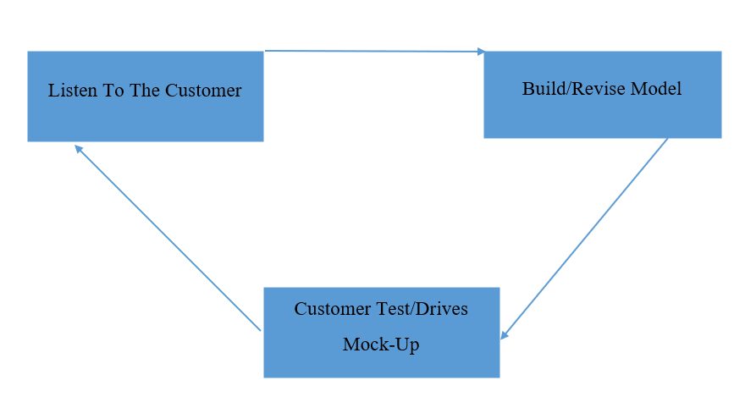

Prototype is a process which is basically developed where,

1] User is not sure of the requirement.

2] Develop make in unsure of the efficiency of a particular algorithm.

Prototype model gives just outline or idea about the system.it does not contain all the document.

Prototype model gives a quick design which focus on the aspect that should be receivable the customer so, that is changes are required it can be done in initial status prototype is a recursive model because the working model is change repeated when the customer need changes.

**Steps In Prototype Model :-**

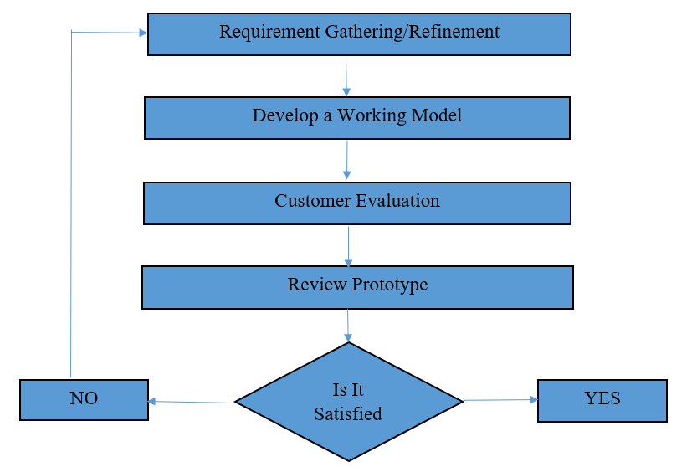

**1] Requirement gathering & Refinement**

Both developer & customer work together and define overall Object of the software and identify the requirements which are to be fulfilled.

**2] Develop a Working Model**

A working model which has important feature is develop so that customer in identify any extra feature is develop so that customer in identify any extra feature acquired or error in application.

**3] Customer Evaluation**

User is give chance to work on the prototype model and evaluated. This can help finding the changes to be alone.

**4] Review Prototype**

The prototype is review for is efficiency and it is determined it changes is required if the user requires a changes refinement in requirement is done of is prototype model is implemented.

The process of prototyping repeated till both the user & developer find all the necessary feature that are required for the problem solved.

**Advantages of Prototype**

1] Misunderstanding between develop team & user can be identify as customer uses the prototype version of s/w.

2] If the software is not user friendly it can be identify in the early stages.

3] The cost of software is very less.

4] System can be delivered within proper time and delay are minimize.

**Disadvantages of prototype**

1] There may be too much variation in requirements each time the prototype is evaluated by the customer.

2] Poor Documentation due to continuously changing customer requirements.

3] It is very difficult for the developers to accommodate all the changes demanded by the customer.

* "A system model is the conceptual model as a result of system modeling that describes and represents a system."
* A system comprises multiple views such as planning, requirement analysis, design, implementation, deployment, structure, behavior, input data, and output data views.
* The system model describes and represents the multiple views possibly using two different approaches. The first one is the "non- architectural approach" and the second one is the "architectural approach".
* The non-architectural approach respectively picks a model for each view. For example, Structured Systems Analysis and Design Method (SSADM), picking the Structure Chart (SC) for structure description and the Data Flow Diagram (DFD) for behaviour description, is categorized into the non-architectural approach.
* The architectural approach instead of picking many heterogeneous and unrelated models, will use only one single coalescence model. For example, System architecture, using the Architecture Description Language (ADL) for both structure and behaviour descriptions, is categorized into the architectural approach.

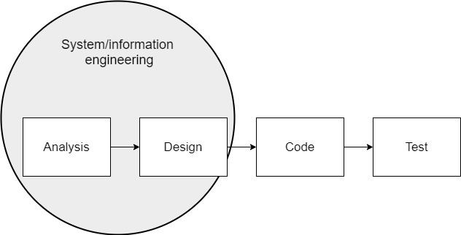

**3.3 Feasibility Study**

**3.3.1 Economical Feasibility**

Among the most important information contained in feasibility study is Cost Benefit Analysis and assessment of the economic justification for a computer-based system project. Cost Benefit Analysis delineates costs for the project development and weighs them against tangible and intangible benefits of a system. Cost Benefits Analysis is complicated by the criteria that vary with the characteristics of the system to be developed, the relative size of the project and the expected return on investment desired as part of company’s strategic plan. In addition, many benefits derived from a computer-based system are intangible. (e.g., better design quality through iterative optimization, increased user satisfaction through programmable control etc.)

**3.3.2 Technical Feasibility**

During technical analysis, the technical merits of the system are studied and at the same time collecting additional information about performance, reliability, maintainability and predictability.

As the software is very much economically feasible, then it is really important for it to be technically sound. The software will be built among:

* MySQL Server as Back End
* Laravel Framework

**3.3.3 Behavioural Feasibility**

Behaviourally also the proposed system is feasible. A particular application may be technically and but may fail to produce the forecasted benefits, because the company is not able to get it to work. For the system, it is not necessary that the user must be a computer expert, but any computer operator given a little bit of knowledge and training can easily operate.

Our proposed project "Movie Ticket Booking System" is operationally feasible since there is no need for special training of staff member and whatever little instructing on this system is required can be done so quite easily and quickly as it is essentially. This project is being developed keeping in mind the general people who one has very little knowledge of computer operation, but can easily access their required database and other related information. The redundancies can be decreased to a large extent as the system will be fully automated.

**4. Risk Identification and Management**



**4.1 Risk Monitoring**

Risks which are possible: -

* As we are not much experienced in professional software development, our team might have difficulties in building elegant solution.
* We might have specified or decided to provide some requirement that we are not sure of fulfilling and that may lead to confusion and schedule problems during later stages in project.
* Project might suffer from lack of schedule due to possible breaks in schedule caused by other activity.

Actions which are taken by us: -

* We are trying to study more and more professionally developed online applications so we can include maximum features.
* We have decided to evaluate specifications at regular intervals for feasibility and refine it if necessary.
* We have prepared project schedule in such way that we get enough time for project work along with other preparations.

**RMMM (Risk Mitigation, Monitoring and Management Plan):**

|  |  |  |  |
| --- | --- | --- | --- |
| **Risk** | **Probability** | **Impact** | **RMMM** |
| Inappropriate version of packages and development tool | 60% | Marginal | Carefully select the specific versions of tools and components to use and ensure that every member will adhere to the choice throughout the entire project. |
| Failure to meet deadlines for deliverable | 20% | Negligible | Setup milestones ahead of the final due date for each deliverable |
| Occurrences of lots of bugs | 30% | Critical | Proper testing technology is used in order to solve most errors. |
| Technology will not meet expectation. | 20% | Moderate | Exploring alternatives for the outdated technologies. |

**5. Technology Used for Development**



We used technology for Front-end tools are PHP & LARAVEL and Back-end tools are MySQL. Also, extra tools are JavaScript, AJAX, jQuery, HTML5 and CSS3.

**5.1 Front-End Tools**

**PHP**

**LARAVEL**

**PHP Introduction:**

PHP code is usually processed on a web server by a PHP interpreter implemented as a module, a daemon or as a Common Gateway Interface (CGI) executable. On a web server, the result of the interpreted and executed PHP code – which may be any type of data, such as generated HTML or binary image data – would form the whole or part of an HTTP response. Various web template systems, web content management systems, and web frameworks exist which can be employed to orchestrate or facilitate the generation of that response. Additionally, PHP can be used for many programming tasks outside the web context, such as standalone graphical applications. PHP code can also be directly executed from the command line.



The standard PHP interpreter, powered by the Zend Engine, is free software released under the PHP License. PHP has been widely ported and can be deployed on most web servers on a variety of operating systems and platforms.

**Features of PHP**

PHP manages freeing all resources users does not require to free file handle resources, database resources, memory etc. unless programmer need to free resource during script execution PHP also have reference count feature. For example, Memory foe variable is shared with it assigned to another variable. If shared with assigned to another variable.

For example, programmers does not have to use pass by reference for large parameter for better performance with PHP. It would be a nice section for new PHP users if there is “Responding Handling” section or like explanation about reference count feature in PHP would be very helpful to write better PHP scripts also.

**Features:** 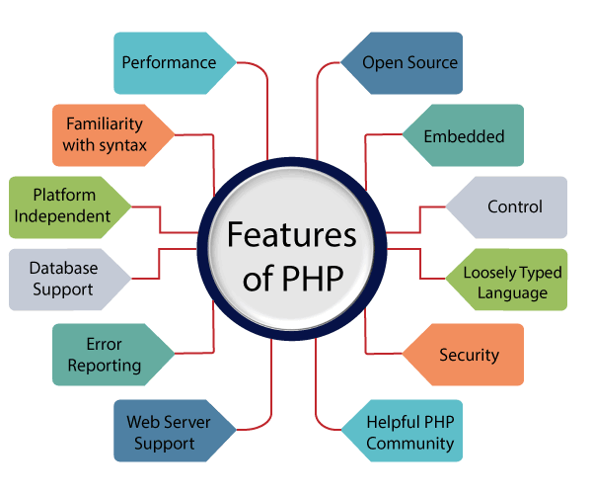

**LARAVEL Introduction:**

Laravel is a web application framework with expressive, elegant syntax. A web framework provides a structure and starting point for creating your application, allowing you to focus on creating something amazing while we sweat the details.

Laravel strives to provide an amazing developer experience while providing powerful features such as thorough dependency injection, an expressive database abstraction layer, queues and scheduled jobs, unit and integration testing, and more.



Whether you are new to PHP or web frameworks or have years of experience, Laravel is a framework that can grow with you. We'll help you take your first steps as a web developer or give you a boost as you take your expertise to the next level. We can't wait to see what you build.

**Features:**

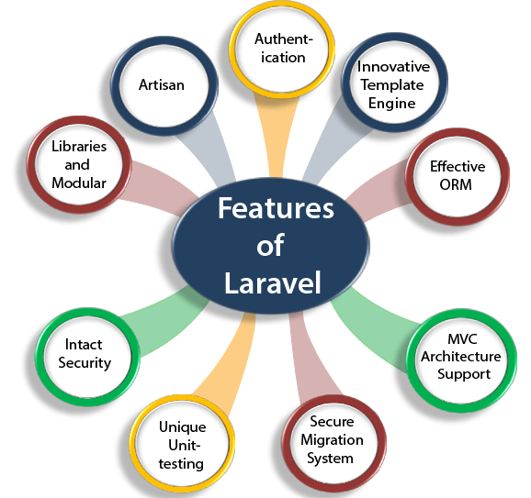

**5.2 Back-End Tools**

**MySQL**

**MySQL Introduction:**

MySQL is an open-source Relational Database Management System MySQL is very fast reliable and flexible Database Management System. It provides a very high performance and it is multi-threaded and multi–Relational Database Management System.

MySQL is one of the most popular relational Database Management System on the web. The MySQL Database has become the world's most popular open-source Database, becomes it is free and available on almost all the platform on UNIX, Windows and Mac OS. MYSQL is used for the internet application as it provides good speed and is very secure MySQL was developed run to manage large volumes of data at very high speed to overcome the problems of existing solution MySQL can be used for verify of application but it is mostly used for the web application on the internet.

The MySQL development project has made its source code available under the terms of the GNU General public License, as well as under a variety of proprietary agreement. MySQL was owned and sponsored by a single for profile firm, the Swedish Company MySQL AB, now owned but Oracle Corporation.



**Features:**

* MySQL is a relational database management system. This database language is based on the SQL queries to access and manage the records of the table.
* MySQL is easy to use. We have to get only the basic knowledge of SQL. We can build and interact with MySQL by using only a few simple SQL statements.
* MySQL consists of a solid data security layer that protects sensitive data from intruders. Also, passwords are encrypted in MySQL.
* MySQL follows the working of a client/server architecture. There is a database server (MySQL) and arbitrarily many clients (application programs), which communicate with the server; that is, they can query data, save changes, etc.
* MySQL is free to use so that we can download it from MySQL official website without any cost.
* MySQL supports multi-threading that makes it easily scalable. It can handle almost any amount of data, up to as much as 50 million rows or more. The default file size limit is about 4 GB. However, we can increase this number to a theoretical limit of 8 TB of data.
* MySQL is considered one of the very fast database languages, backed by a large number of the benchmark test.
* MySQL supports a large number of embedded applications, which makes MySQL very flexible.
* MySQL allows transactions to be rolled back, commit, and crash recovery.

**5.3 Extra Tools**

**JAVASCRIPT**

**HTML5**

**CSS3**

**jQuery**

**AJAX**

**JAVASCRIPT Introduction:**

JavaScript is the prototype-based scripting language that is dynamic, weakly typed and has first class function it is a multi-paradigm language supported objected oriented, imperative and functional programming style.

JavaScript was formalized in the ECSMAS Script language standard and in primary used in the form of client-side JavaScript implements as part of web browser in order to provide enhance used interface and dynamic website this enable programmatic access to the computational object within a host environment.



JavaScript is used in the application outside web pages for example in PDF documents, site specific browser and desktop widgets is also significant newer and faster JavaScript CMS and framework built upon then have also increased the popularity of JavaScript for server-side web application.

JavaScript user influenced but then of C JavaScript copies meant names and naming conversation from Java but the two languages are otherwise unrelated and very difficult semantics the key design principals with JavaScript and taken from the self and scheme programming language.

**HTML5 Introduction:**

HTML stands for Hyper Text Markup Language. It is used to design web pages using a markup language. HTML is the combination of Hypertext and Markup language. Hypertext defines the link between the web pages. A markup language is used to define the text document within tag which defines the structure of web pages. This language is used to annotate (make notes for the computer) text so that a machine can understand it and manipulate text accordingly. Most markup languages (e.g., HTML) are human-readable. The language uses tags to define what manipulation has to be done on the text.



HTML is a markup language used by the browser to manipulate text, images, and other content, in order to display it in the required format. HTML was created by Tim Berners-Lee in 1991. The first-ever version of HTML was HTML 1.0, but the first standard version was HTML 2.0, published in 1999.

**CSS3 Introduction:**

Cascading Style Sheets, fondly referred to as CSS, is a simply designed language intended to simplify the process of making web pages presentable. CSS allows you to apply styles to web pages. More importantly, CSS enables you to do this independent of the HTML that makes up each web page.



CSS is easy to learn and understand, but it provides powerful control over the presentation of an HTML document.

**jQuery Introduction:**

jQuery is an open-source JavaScript library that simplifies the interactions between an HTML/CSS document, or more precisely the Document Object Model (DOM), and JavaScript. Elaborating the terms, jQuery simplifies HTML document traversing and manipulation, browser event handling, DOM animations, Ajax interactions, and cross-browser JavaScript development.



jQuery is a JavaScript library designed to simplify HTML DOM tree traversal and manipulation, as well as event handling, CSS animation, and Ajax. It is free, open-source software using the permissive MIT License. As of May 2019, jQuery is used by 73% of the 10 million most popular websites.

jQuery is widely famous with its philosophy of “Write less, do more.” This philosophy can be further elaborated as three concepts:

* Finding some elements (via CSS selectors) and doing something with them (via jQuery methods) i.e., locate a set of elements in the DOM, and then do something with that set of elements.
* Chaining multiple jQuery methods on a set of elements
* Using the jQuery wrapper and implicit iteration

**AJAX Introduction:**

AJAX = Asynchronous JavaScript and XML.

AJAX is a technique for creating fast and dynamic web pages.



AJAX allows web pages to be updated asynchronously by exchanging small amounts of data with the server behind the scenes. This means that it is possible to update parts of a web page, without reloading the whole page.

Classic web pages, (which do not use AJAX) must reload the entire page if the content should change. Examples of applications using AJAX: Google Maps, Gmail, Youtube, and Facebook tabs.

**6. Planning**



**6.1 System Planning**

Today, the demands for a new or enhancement of the system exceeds the ability and resources of most organizations to conduct system development projects.

System Planning is the first phase in the system development life cycle. System Planning is where an organization’s total information needs are identified, analyzed , prioritized and arranged. Organization creates and assesses the original goals and expectation of a new system.

Planning phase starts with reviewing the request towards system development. The two major activities involved in system planning are :

* **Identifying The System Development Project**
* **Planning The System Development Project**

**6.1.1 Identifying The System Development Project**

There are two ways on how to identify the needs for system development either by top-down planning and bottom-up planning. Top-down planning is where the top management asks the IT support or unit within their organization to develop a system. They will identify and assesses if there is any possible system development projects organization can be done. Bottom-up planning is also known as a user request planning. User’s request is when users need the system in order to fulfill or help their daily job easily. For the following discussion, we’ll consider the second option; the system request is from the user. The starting point of information system project is called a system service request. A system service request might propose enhancements for an existing system, the correction of problems or errors, or the development of entirely new information system.

There are several reasons why user sends for the system service request :

**Improved services offered**

This is the most basic reason why we need a new or enhanced system. A new or enhanced system is important to improve services for users or users within the organization.

**Support for new products or new services**

New product developed or new services introduced require new types of IT support.

**Provide more information**

The system might produce information which is not enough in order to support the organization’s changing information needs.

**6.1.2 Planning The System Development Project**

Some other methodologies refer it as preliminary investigation phase, initial study phase, or planning phase. System analysts always conduct a preliminary investigation to study the system service request and recommend the specific action base on that. This activity is important to initiate the project. After getting the approval from the management, the analysts interact with the stakeholders involved such as system owner, project managers and system user to gather information. The analyst responsibility is to gathers the information about the problems or opportunity, project scope and constraints, project benefits, and budget for development time and costs. Then, analyst will prepare a report to the management.

During the preliminary investigation, a system analyst typically follows a series of steps. System analyst might use tool such as Microsoft Project to plan and manage his/her task in this phase. A proper plan of system development is important to make sure that the system is within the scope, within the budget, and finish at the specific time.

From the system service request, we’ll know either the project is a new information system development or upgrading the current information system. The important task in this step is establishing an initial problems, opportunities and directives that triggered the project. The team needs to learn about the current system. System owner, system analyst and system user have a different level of understanding from the system. After learning the entire system, the project team will sit together to analyze the problem and opportunities arise. During this session, project team ask the system owner and system users several type of questions to gain more understanding to leads to possible new system. They analyzed the problems based on cause-and-effect analysis.

**Define the project scope and constraints**

Determining the project scope means defining the specific boundaries of the project. It’s important to define the project scope because it will limit the project development scope. Scope definition activity is concerned primarily with system owners’ view of the existing system and what are the problems or opportunities that come out with the interest of system service request. Scope is the boundaries of a project –the areas of a business that a project may (or may not) address.

Along with the project scope, system analyst needs to identify if there is any possible constraints on the system. A constraint is a requirement or condition that the system must satisfy or an outcome that the system must achieve. A constraint can be derived from hardware, software, time, organization policy and others.

After defining the project scope, the team can establish the system development objectives. Normally, system objectives can be derived after identifying the problem and scopes. System objectives is important because by the end of the system development, a measurement will be conducted to validate either the project has meets the objectives or not.

**Perform fact-finding**

Fact-finding involves several techniques depends on what types of information will be gathered. It can take several hours or maybe up to several weeks. During this activity, fact-finding techniques are required to gather basic information about the future system.

**Present results and recommendation to management**

At the end of this activity, a baseline project plan is prepared and presents it to the management. This task is triggered by the completion of the project plan. The project team will write a report and present the result and recommendation to the management. The decision will be made after this presentation either one from this decision:

* authorize the project to be continued
* make an adjustment such as the scope, time, budget and schedule
* cancel the project.

If the project will be continued, it may proceed to the next step; system analysis. If the project should be cancelled, they will stop the task. There are several reasons why the project should be cancelled such as lack of resources, realization that the problem is not too important, or realization that the cost of the development is too high

**6.2 Time Line Chart**

|  |  |  |  |  |  |  |  |  |  |  |  |  |  |  |
| --- | --- | --- | --- | --- | --- | --- | --- | --- | --- | --- | --- | --- | --- | --- |
| Week | 1 | 2 | 3 | 4 | 5 | 6 | 7 | 8 | 9 | 10 | 11 | 12 | 13 | 14 |
| Date | 3 | 10 | 17 | 24 | 7 | 14 | 21 | 28 | 7 | 14 | 21 | 28 | 1 | 4 |
| Month | January | | | | February | | | | March | | | | April | |
| Activity |
| Domain Under Standing |  |  |  |  |  |  |  |  |  |  |  |  |  |  |
| Further Analysis |  |  |  |  |  |  |  |  |  |  |  |  |  |  |
| Learning Process |  |  |  |  |  |  |  |  |  |  |  |  |  |  |
| Design |  |  |  |  |  |  |  |  |  |  |  |  |  |  |
| Coding and Testing |  |  |  |  |  |  |  |  |  |  |  |  |  |  |
| Documentation |  |  |  |  |  |  |  |  |  |  |  |  |  |  |
| Final Documentation |  |  |  |  |  |  |  |  |  |  |  |  |  |  |

**7. System Analysis**



**7.1 Database Design**

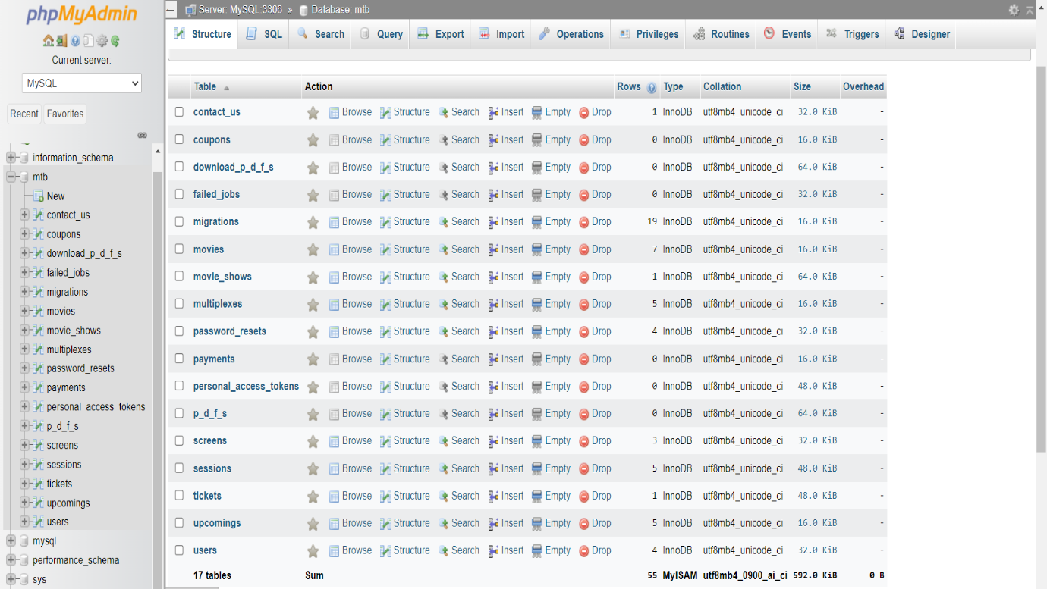

**Table Name: users**

|  |  |  |  |
| --- | --- | --- | --- |
| **Field Name** | **Data Type** | **Constraint** | **Description** |
| id | Bigint | Primary Key | Auto generated id (User id, Admin id) |
| name | Varchar | Not Null | User and Admin Name |
| email | Varchar | Foreign Key | User email and Admin Email |
| phone | Varchar | Null | User Phone and Admin Phone |
| city | Varchar | Null | User City and Admin City |
| role | Varchar | Not Null | User Role and Admin Role  (User=0,Admin=1) |
| email_verified_at | Timestamp | Null | Time at which email is verified |
| password | Varchar | Not Null | Encrypted Password |
| two_factor_secret | Text | Null | Code for Two factor Authentication |
| two_factor_  recovery_codes | Text | Null | Encrypted Recovery Codes |
| remember_token | Varchar | Null | Current Session Token |
| current_team_id | Bigint | Null | Team id |
| profile_photo_path | Varchar | Null | Profile Photo path |
| created_at | Timestamp | Null | Row Created at which time |
| updated_at | Timestamp | Null | Row updated at which time |

**Table Name: movies**

|  |  |  |  |
| --- | --- | --- | --- |
| **Field Name** | **Data Type** | **Constraint** | **Description** |
| id | Bigint | Primary Key | Auto generated id (Movie id) |
| moviename | Varchar | Not Null | Name of the Movie |
| description | Varchar | Not Null | Description of the Movie |
| releasedate | Varchar | Not Null | Release Date of the movie |
| genre | Varchar | Not Null | Genre of the Movie |
| type | Varchar | Not Null | Movie Type(2D,3D,4DX) |
| length | Varchar | Not Null | Length of the movie |
| trailerlink | Varchar | Not Null | Embedded trailer link of the movie |
| slug | Varchar | Not Null | Movie Slug Name |
| rating | Varchar | Not Null | Movie Ratings |
| cast | Varchar | Not Null | Cast of the movie |
| image | Varchar | Not Null | Movie Image |
| lang | Varchar | Not Null | Movie Shows are available at which language |
| imdb | Varchar | Not Null | IMDB Rating of the movie |
| rt | Varchar | Not Null | Rotten Tomatoes rating of the movie |
| created_at | Timestamp | Null | Row Created at which time |
| updated_at | Timestamp | Null | Row Updated at which time |

**Table Name: multiplexes**

|  |  |  |  |
| --- | --- | --- | --- |
| **Field Name** | **Data Type** | **Constraint** | **Description** |
| id | Bigint | Primary Key | Auto generated id (Multiplex id) |
| name | Varchar | Not Null | Multiplex Name |
| address | Varchar | Not Null | Multiplex Address |
| contact | Varchar | Not Null | Contact information of the multiplex |
| email | Varchar | Not Null | Email Address of the multiplex |
| totalscreen | Varchar | Not Null | Total Screen Available in the particular multiplex |
| created_at | timestamp | Null | Row created at which time |
| updated_at | Timestamp | Null | Auto generated id (Multiplex id) |

**Table Name: movie_shows**

|  |  |  |  |
| --- | --- | --- | --- |
| **Field Name** | **Data Type** | **Constraint** | **Description** |
| id | Bigint | Primary Key | Auto generated id (Movie Show id) |
| movieid | Bigint | Foreign Key | Movie id |
| multiplexid | Bigint | Foreign Key | Multiplex Id |
| screenid | Bigint | Foreign Key | Screen id |
| showdate | Date | Not Null | All dates at which movie shows are available |
| showtime | Time | Not Null | All dates at which movie shows are available |
| showtype | varchar | Not Null | Show Type (2D,3D,4DX) |
| showlang | varchar | Not Null | Language available for a particular movie show |
| normalprice | varchar | Not Null | Normal Ticket Price for a particular movie show |
| executiveprice | varchar | Not Null | Executive Ticket Price for a particular movie show |
| premiumprice | varchar | Not Null | Premium ticket Price for a particular movie show |
| totalseats | Varchar | Not Null | Total Seats available for movie show |
| created_at | Timestamp | Null | Row created at which time |
| updated_at | Timestamp | Null | Row updated at which time |

**Table Name: contact_us**

|  |  |  |  |
| --- | --- | --- | --- |
| **Field Name** | **Data Type** | **Constraint** | **Description** |
| id | Bigint | Primary Key | Auto generated id (Contact us id) |
| userid | Bigint | Foreign Key | User id |
| fullname | Varchar | Not Null | User Full Name |
| email | Varchar | Not Null | User email |
| subject | Varchar | Not Null | Subject of the message |
| message | Varchar | Not Null | Message user wants to send |
| created_at | timestamp | Null | Row created at which time |
| updated_at | timestamp | Null | Row updated at which time |

**Table Name: password_resets**

|  |  |  |  |
| --- | --- | --- | --- |
| **Field Name** | **Data Type** | **Constraint** | **Description** |
| email | Varchar | Foreign Key | User email |
| token | Varchar | Not Null | Auto generated token |
| created_at | Timestamp | Null | Row created at which time |

**Table Name: upcomings**

|  |  |  |  |
| --- | --- | --- | --- |
| **Field Name** | **Data Type** | **Constraint** | **Description** |
| id | Bigint | Primary Key | Auto generated id (Upcoming Movie id) |
| moviename | Varchar | Not Null | Upcoming Movie Name |
| description | Varchar | Not Null | Description of the movie |
| realasedate | Varchar | Not Null | Release Date of the movie |
| genre | Varchar | Not Null | Movie genre |
| type | Varchar | Not Null | Movie Type(2D,3D,4DX) |
| trailerlink | Varchar | Not Null | Trailer Link of the movie |
| Slug | Varchar | Not Null | Movie slug name |
| Cast | Varchar | Not Null | All cast of movies |
| image | Varchar | Not Null | Movie image |
| lang | Varchar | Not Null | All languages available of the movie |
| created_at | Timestamp | Null | Row created at which time |
| updated_at | Timestamp | Null | Row updated at which time |

**Table Name: screens**

|  |  |  |  |
| --- | --- | --- | --- |
| **Field Name** | **Data Type** | **Constraint** | **Description** |
| id | Bigint | Primary Key | Auto generated id (Screen id) |
| screenno | Varchar | Not Null | Screen Number |
| screenname | Varchar | Not Null | Screen Name |
| multiplexed | Bigint | Not Null | Multiplex Id |
| created_at | timestamp | Null | Row created at which time |
| updated_at | timestamp | Null | Row updated at which time |

**Table Name: tickets**

|  |  |  |  |
| --- | --- | --- | --- |
| **Field Name** | **Data Type** | **Constraint** | **Description** |
| id | Bigint | Primary Key | Auto generated id (Ticket id) |
| userid | Bigint | Foreign Key | User id |
| user_name | String | Not Null | User name of the person booking tickets for the show |
| movie_name | String | Not Null | Name of the movie |
| movieshowid | Bigint | Foreign Key | Movie show id |
| normalprice | varchar | Not Null | Normal Price of the movie show |
| executiveprice | varchar | Not Null | Executive Price of the movie show |
| premiumprice | varchar | Not Null | Premium Price of the movie show |
| seatnames | varchar | Not Null | Seat Names which the user had booked for the movie show |
| totalseats | varchar | Not Null | Total seats which the user has booked for the movie show |
| bookingdate | Date | Not Null | Booking date of the show |
| totalcost | varchar | Not Null | Total cost the user had paid for tickets |
| totalpay | varchar | Not Null | Total Payment which the user had paid |
| Completed | varchar | Not Null | User had completed the payment of not. |
| created_at | timestamp | Null | Row created at which time |
| updated_at | timestamp | Null | Row updated at which time |

**7.2 System Flow Chart**

Is Login

Enter Username and Password

Is Register

Start

Registration

No

Yes

Yes

No

Yes

Is Admin

Admin Yes No User

Manage screen

Manage user contact

Manage movie shows

Manage upcoming movies

Manage current movies

Manage tickets

Manage user

Manage multiplex

Stop

Logout

Contact Us

Cancel Tickets

Search Movies

Book Tickets

View multiplexes

View Screens

View upcoming movies

View latest movies

**7.3 Entity-Relationship Diagram**

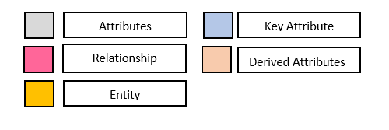

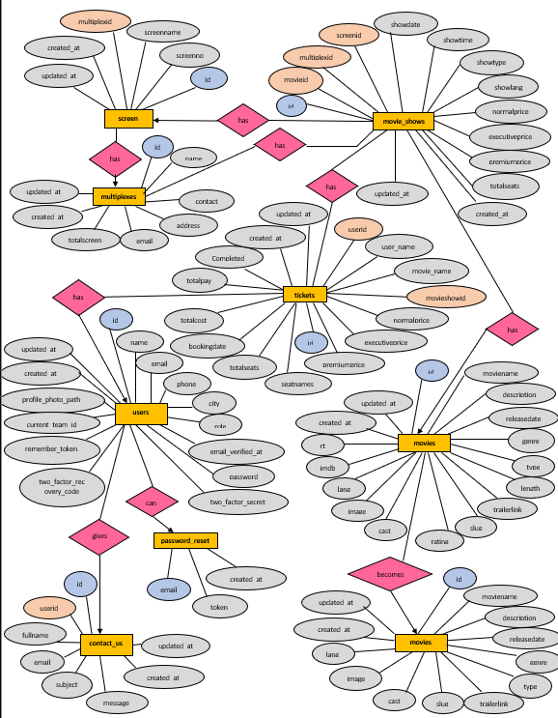

**7.4 Data Flow Diagram**

**0-Level DFD:**

Process

External Entity

Visitor

Update/Manage Information Reserved Seats

Issue Tickets

Admin

Response Book Tickets

User

Email

Update Movie Schedule Payment Information

Movie Information

Cancel Tickets

**1-Level DFD:**

Store Movies Add Movies

Information

Admin

Movie Information

Multiplex Multiplex Management

Management Information

Multiplex Information

Screen Screen Management

Management Information

Screen Management

Movies Movie Management

Management Information

Confirmation

Login Login

Confirmation

Login

Registration Confirmation

User

Signup

Searched Movies Search Movies

Result

Ticket

Booked Movies Information

Payment

Payment Gives Information

**2-Level DFD of Movie Management:**

4.1

Latest Movies

Add movies Insert Data

Added Successfully Inserted

Admin

4.2 Upcoming Movies

Add movies Insert Data Movies

Added Successfully Inserted Management

**2-Level DFD of Login:**

5.1

Login

Login Information Login Detail

Successful / Failed to Login Approval

User

5.2

Password

Inserts Password Verifies Password Login

Logged In Verified

**2-Level DFD of Book Tickets:**

8.1

Seats

Select Seats Reserve Seats

Confirm seats Reserved

Booked

8.2

Confirm Tickets

User

Book Tickets Ticket Details Movies

Successfully Booked Ticket Details

8.3

Cancel Tickets

Cancel Tickets Ticket Details

Successfully Cancelled Ticket Details

**3-Level DFD of Seats:**

8.1.1

Normal

Select Seats Reserve Seats

Confirm seats Reserved

Booked

8.1.2

Executive

User

Select Seats Reserve Seats Movies

Confirm seats Reserved

8.1.3

Premium

Select Seats Reserve Seats

Confirm seats Reserved

**7.5 Data Dictionary**

**Users Table**

|  |  |
| --- | --- |
| **Table Name** | users |
| **Alias Name** | users |
| **Source** | User, Admin |
| **Destination** | Admin |
| **Description** | Information about all users and admin detail. |

**Movies Table**

|  |  |
| --- | --- |
| **Table Name** | movies |
| **Alias Name** | movies |
| **Source** | Admin |
| **Destination** | User |
| **Description** | Information about all movies that are available for movie shows. |

**Upcomings Table**

|  |  |
| --- | --- |
| **Table Name** | upcomings |
| **Alias Name** | upcomings |
| **Source** | Admin |
| **Destination** | User |
| **Description** | Information about all upcoming movies. |

**Multiplexes Table**

|  |  |
| --- | --- |
| **Table Name** | multiplexes |
| **Alias Name** | multiplexes |
| **Source** | Admin |
| **Destination** | User |
| **Description** | Information about all multiplex that are available for movie shows. |

**Screens Table**

|  |  |
| --- | --- |
| **Table Name** | screens |
| **Alias Name** | screens |
| **Source** | Admin |
| **Destination** | User |
| **Description** | Information about all screen that are available for movie shows. |

**Movie Shows Table**

|  |  |
| --- | --- |
| **Table Name** | movie_shows |
| **Alias Name** | movie_shows |
| **Source** | Admin |
| **Destination** | User |
| **Description** | Information about all movie shows. |

**Contact Us Table**

|  |  |
| --- | --- |
| **Table Name** | contact_us |
| **Alias Name** | contact_us |
| **Source** | Admin,User |
| **Destination** | Admin,User |
| **Description** | Information to contact admin for any feedback. |

**Migration Table**

|  |  |
| --- | --- |
| **Table Name** | migrations |
| **Alias Name** | migrations |
| **Source** | Admin |
| **Destination** | User |
| **Description** | Information about all columns that have migrated. |

**Password Resets Table**

|  |  |
| --- | --- |
| **Table Name** | password_resets |
| **Alias Name** | password_resets |
| **Source** | User |
| **Destination** | Admin, User |
| **Description** | Information about password reset of user. |

**Sessions Table**

|  |  |
| --- | --- |
| **Table Name** | sessions |
| **Alias Name** | sessions |
| **Source** | Admin, User |
| **Destination** | Admin |
| **Description** | Information about all user or admin logged in. |

**Tickets Table**

|  |  |
| --- | --- |
| **Table Name** | tickets |
| **Alias Name** | tickets |
| **Source** | User |
| **Destination** | User |
| **Description** | Information about tickets that user has booked. |

**8. Designing**



**8.1 Admin Panel**

**Dashboard :-**

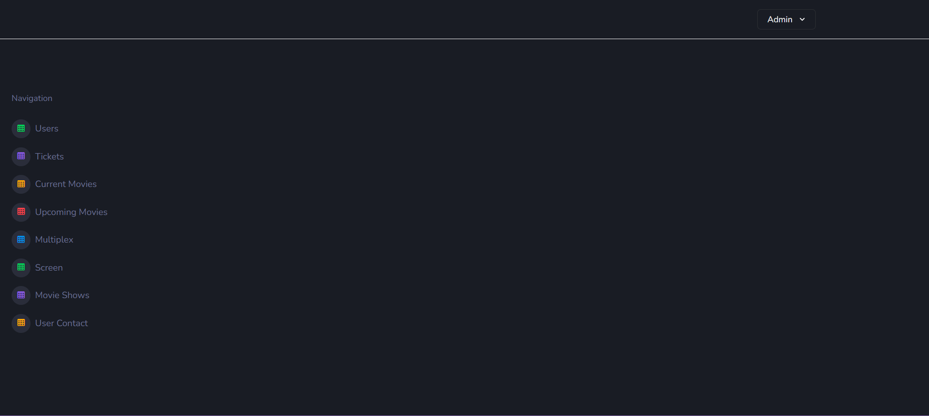

**Users :-**

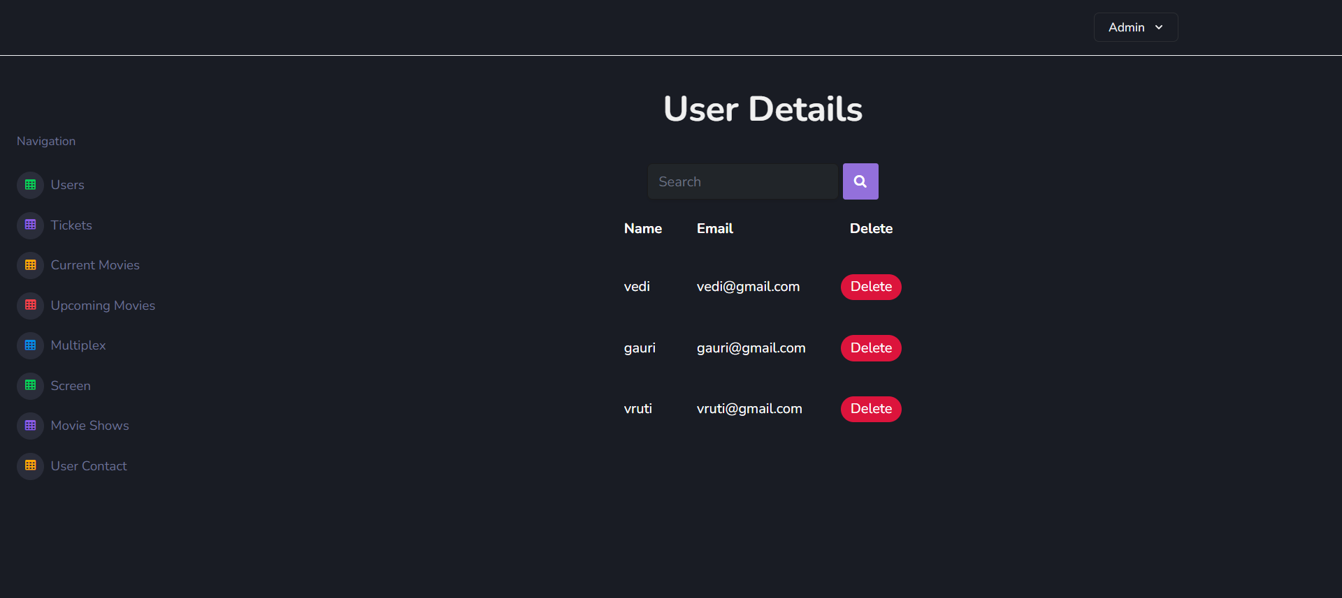

**Delete Users :-**

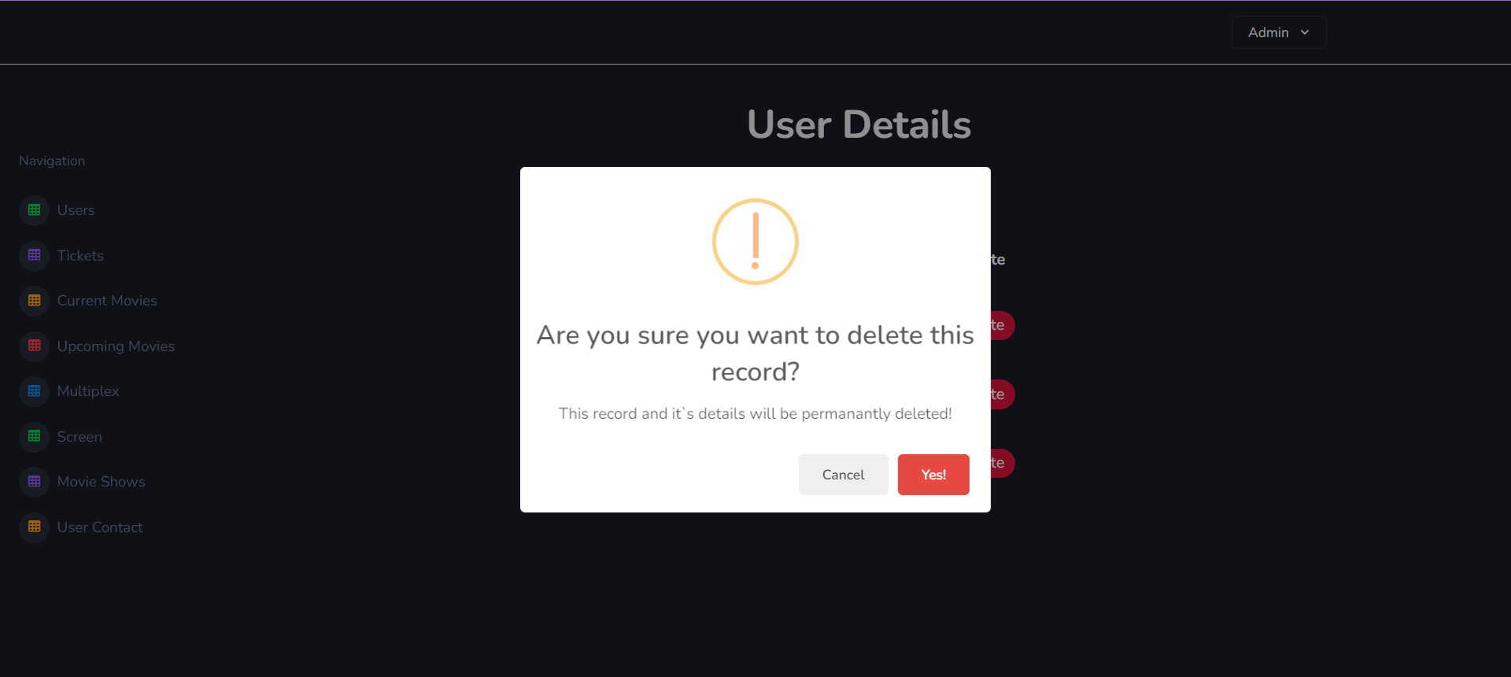

**Search Users :-**

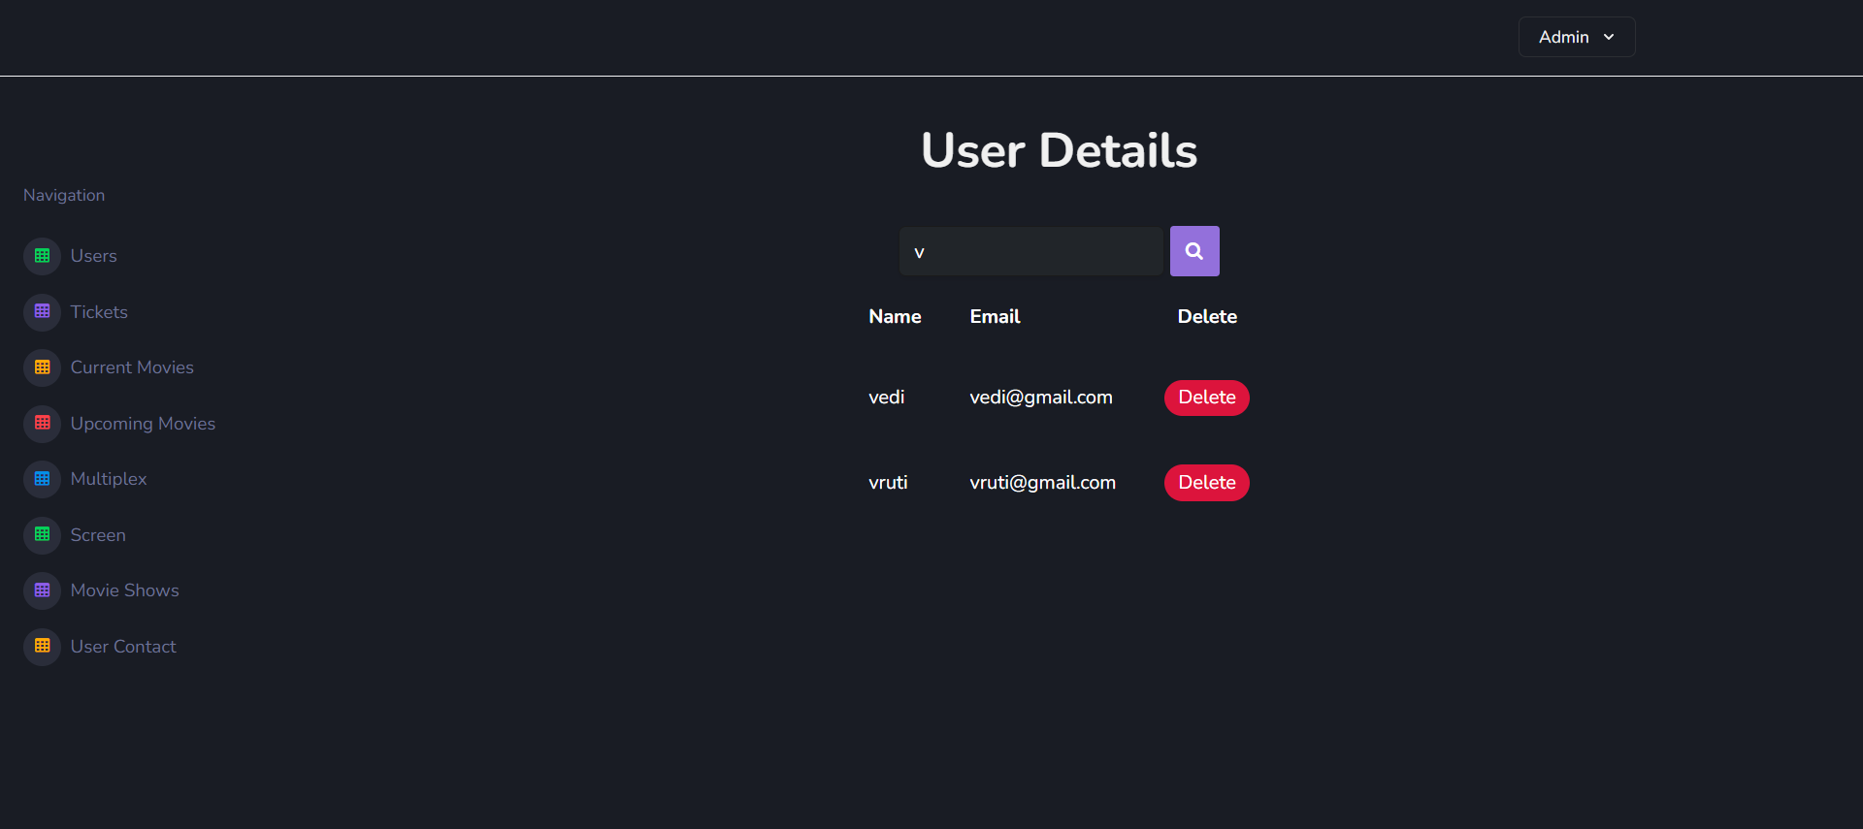

**Tickets :-**

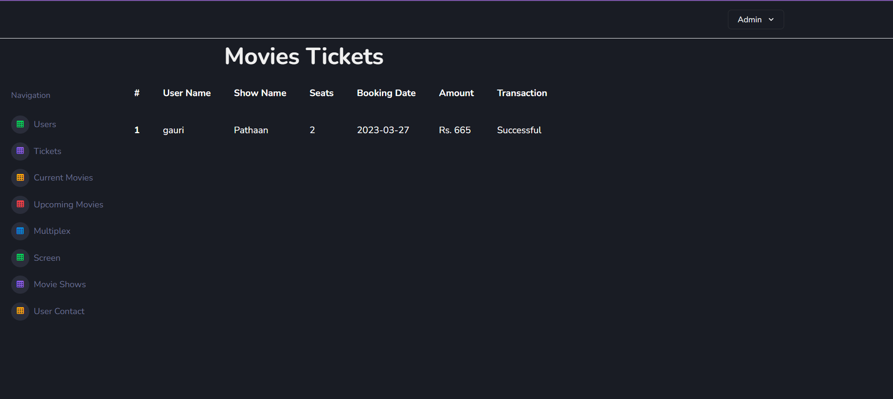

**Current Movies :-**

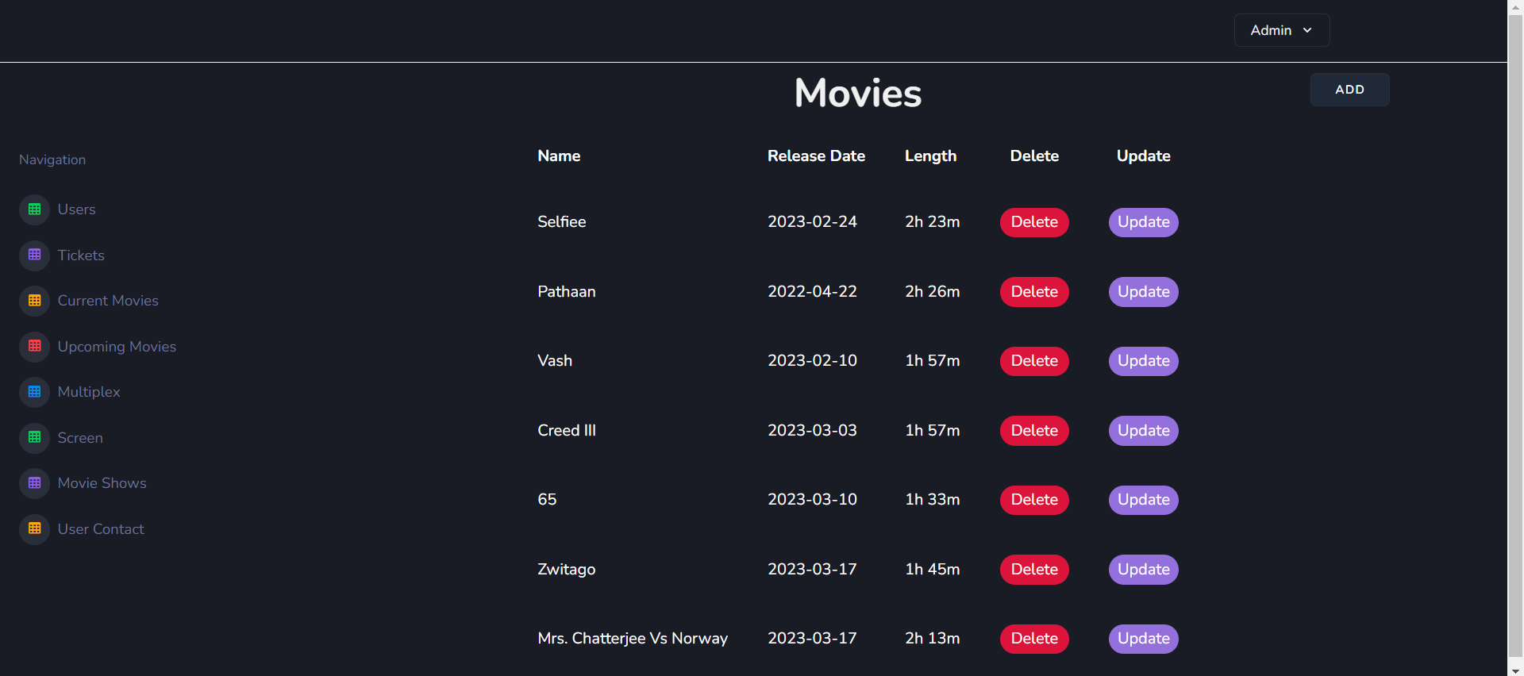

**Delete Movies :-**

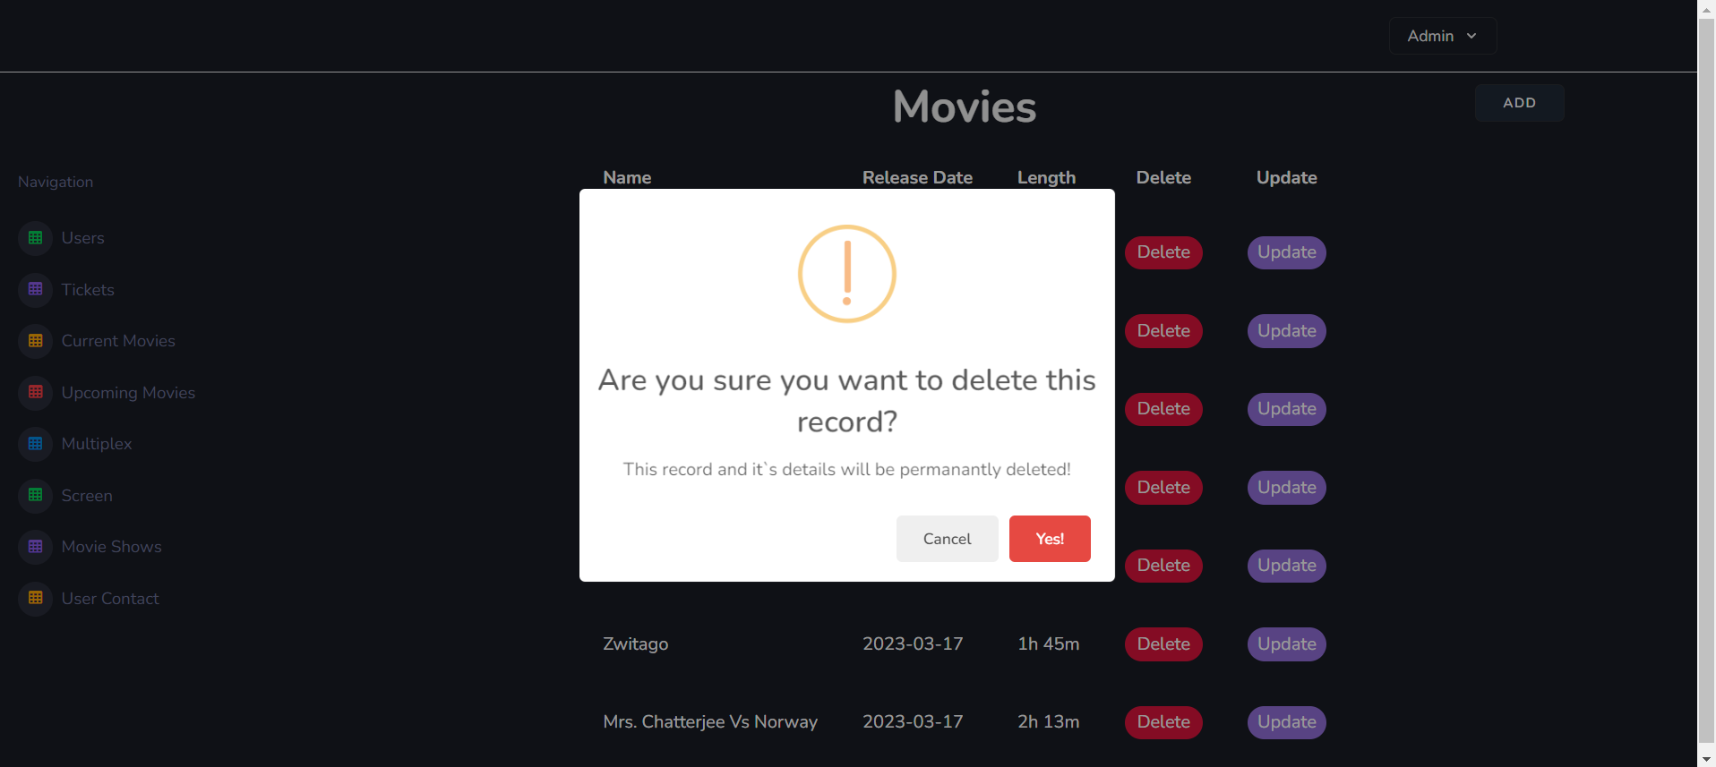

**Add Movies :-**

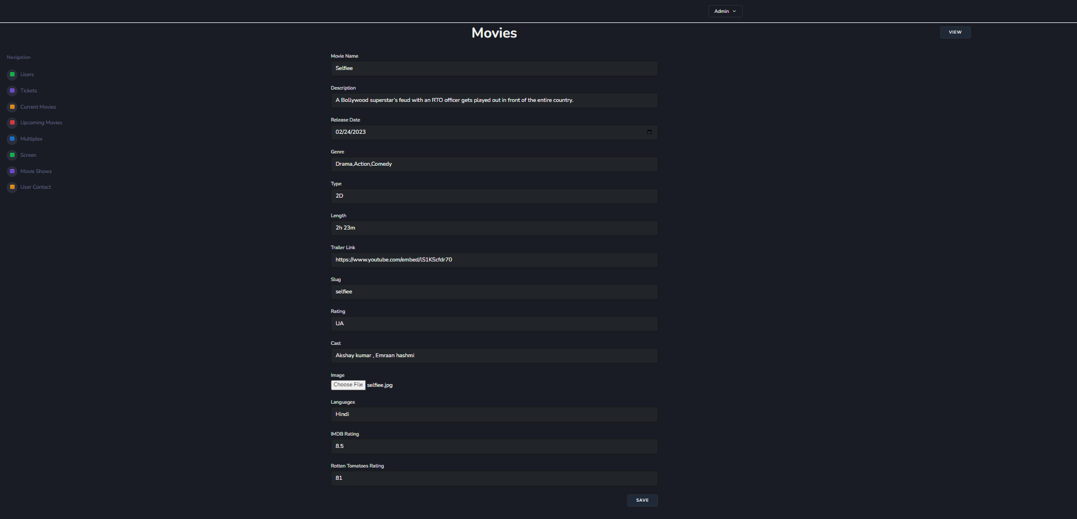

**Update Movies :-**

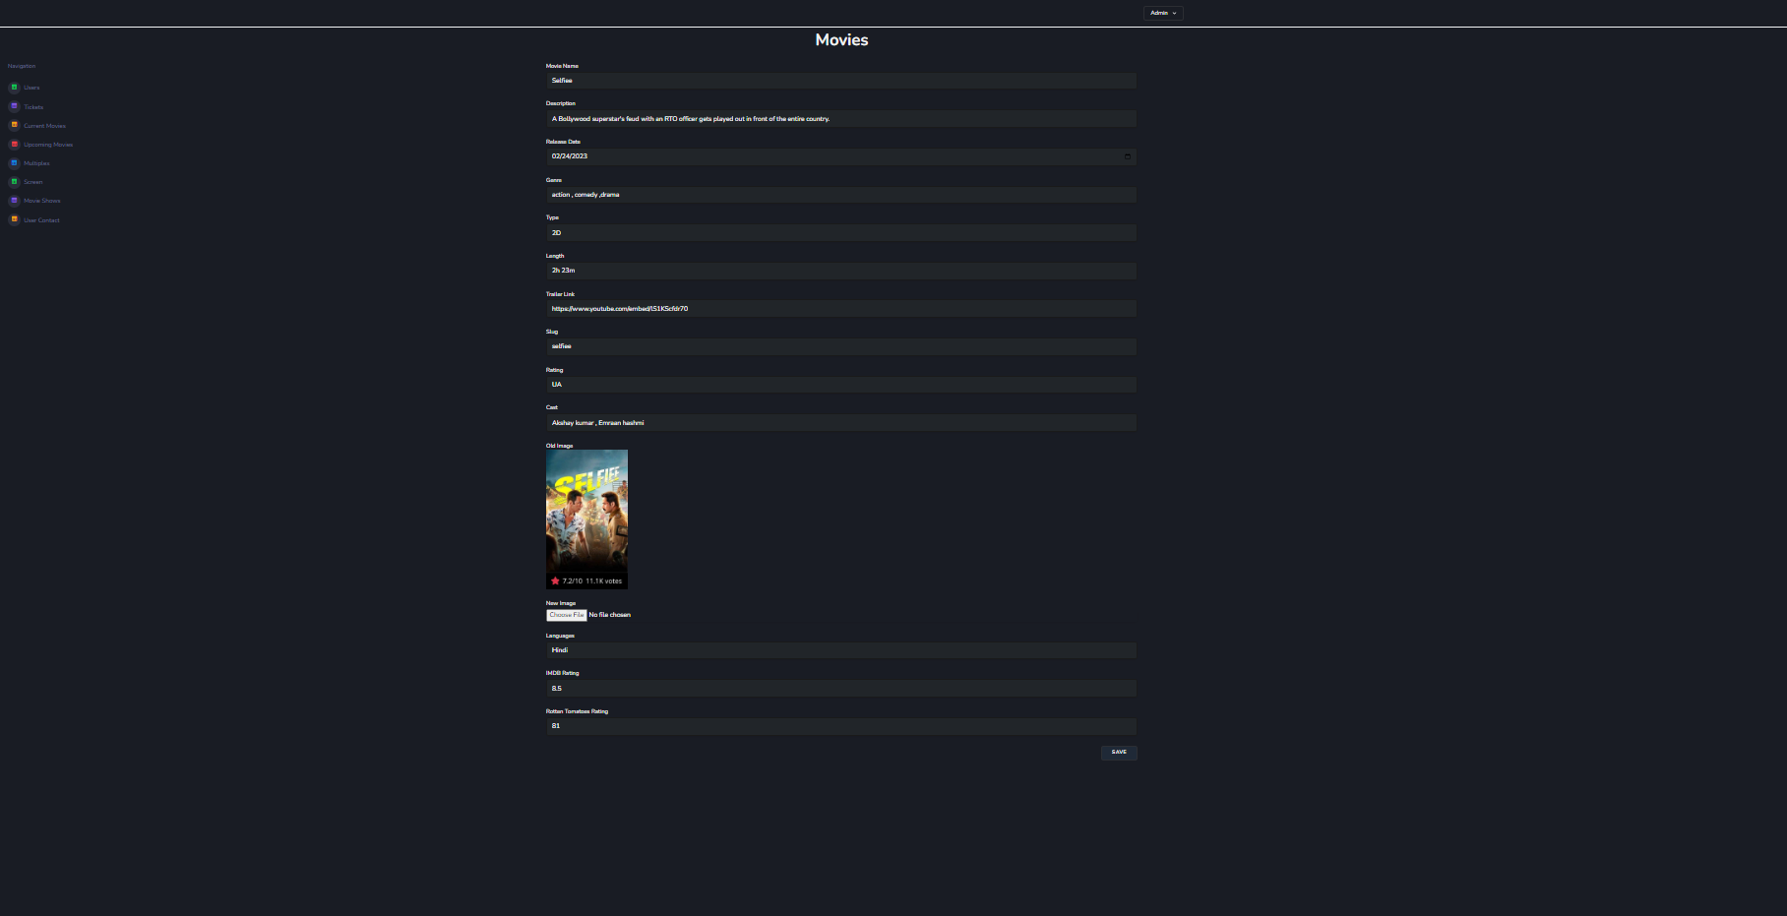

**Upcoming Movies :-**

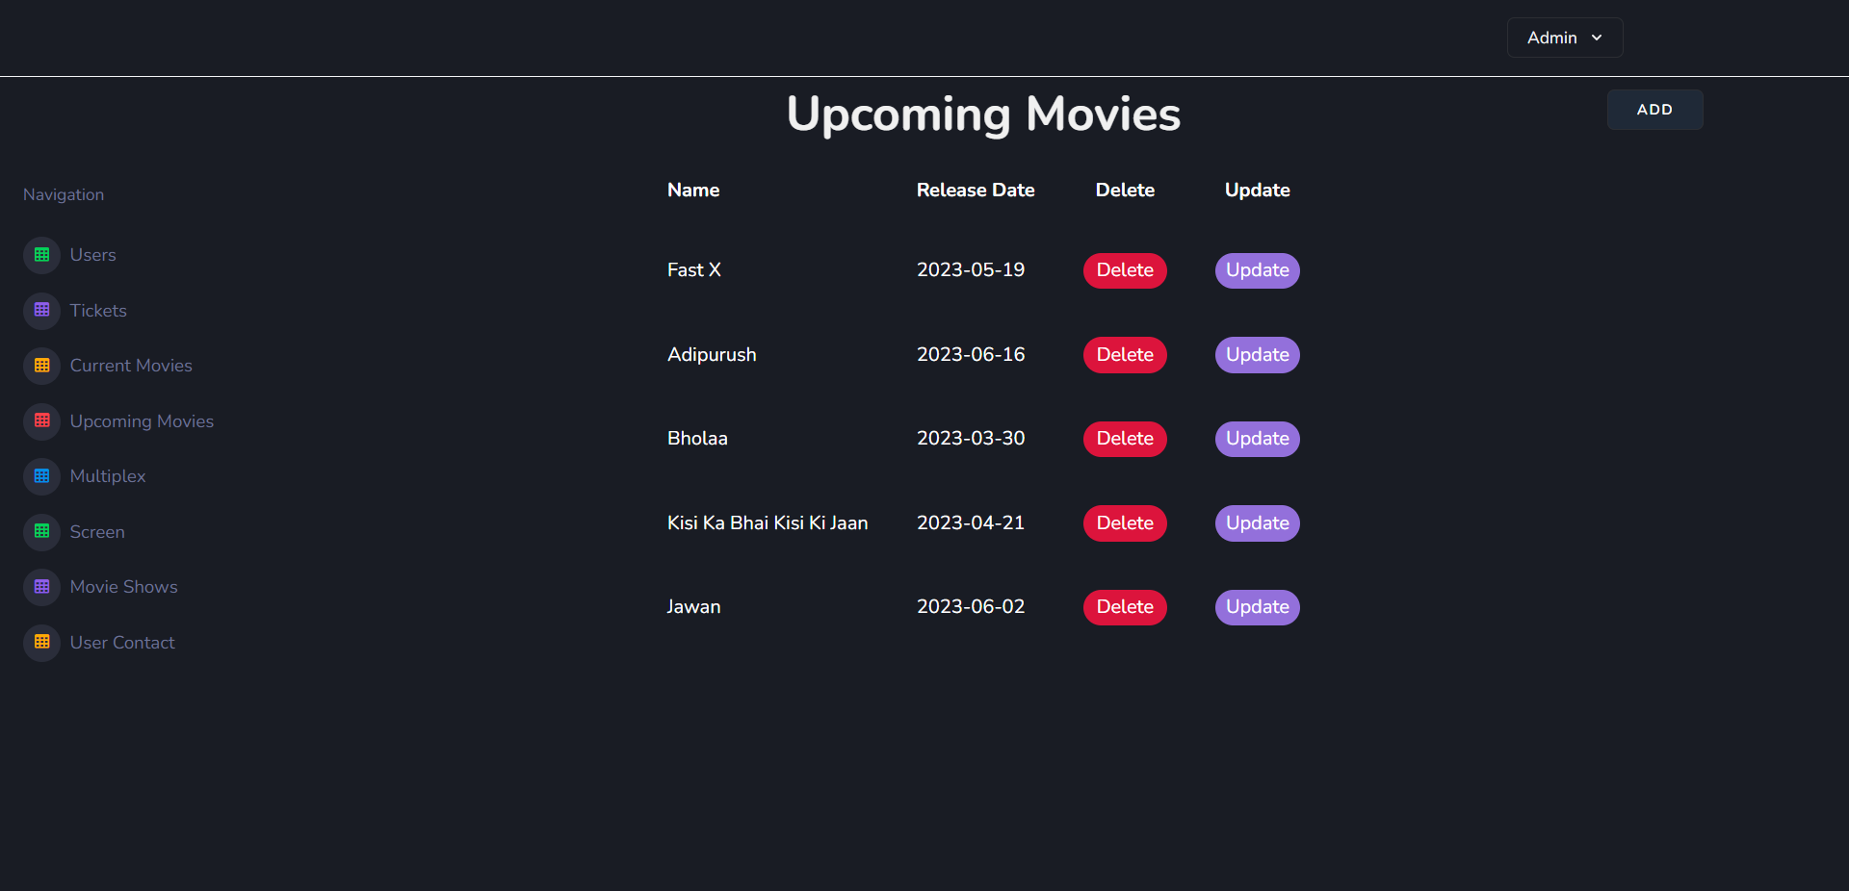

**Delete Upcoming Movies :-**

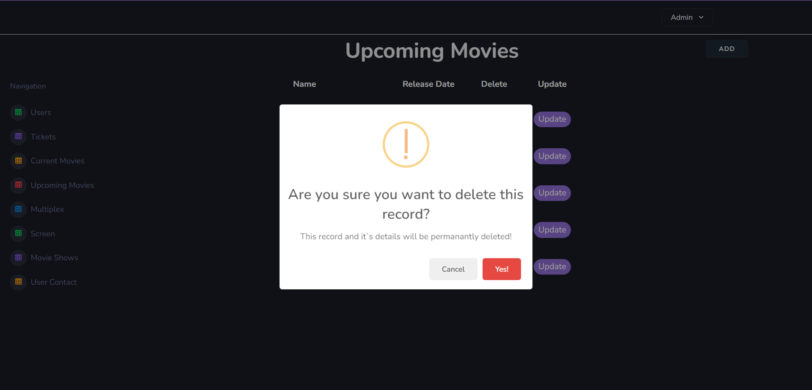

**Add Upcoming Movies :-**

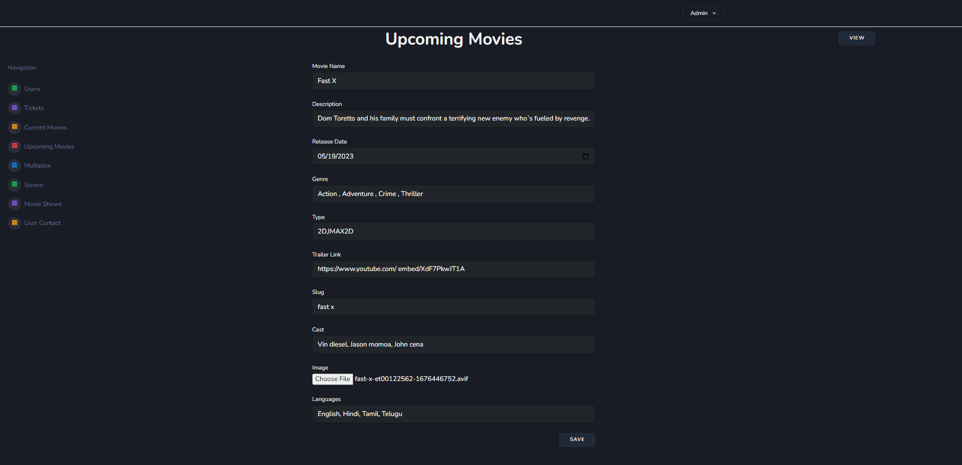

**Update Upcoming Movies :-**

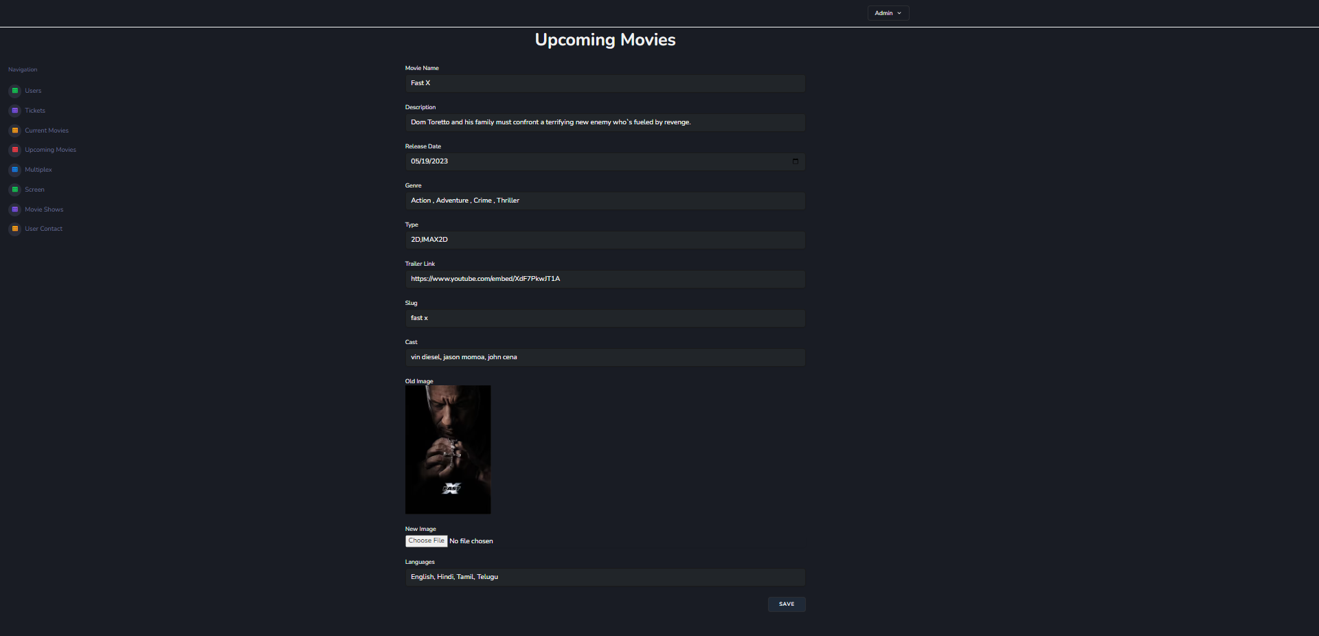

**Multiplex :-**

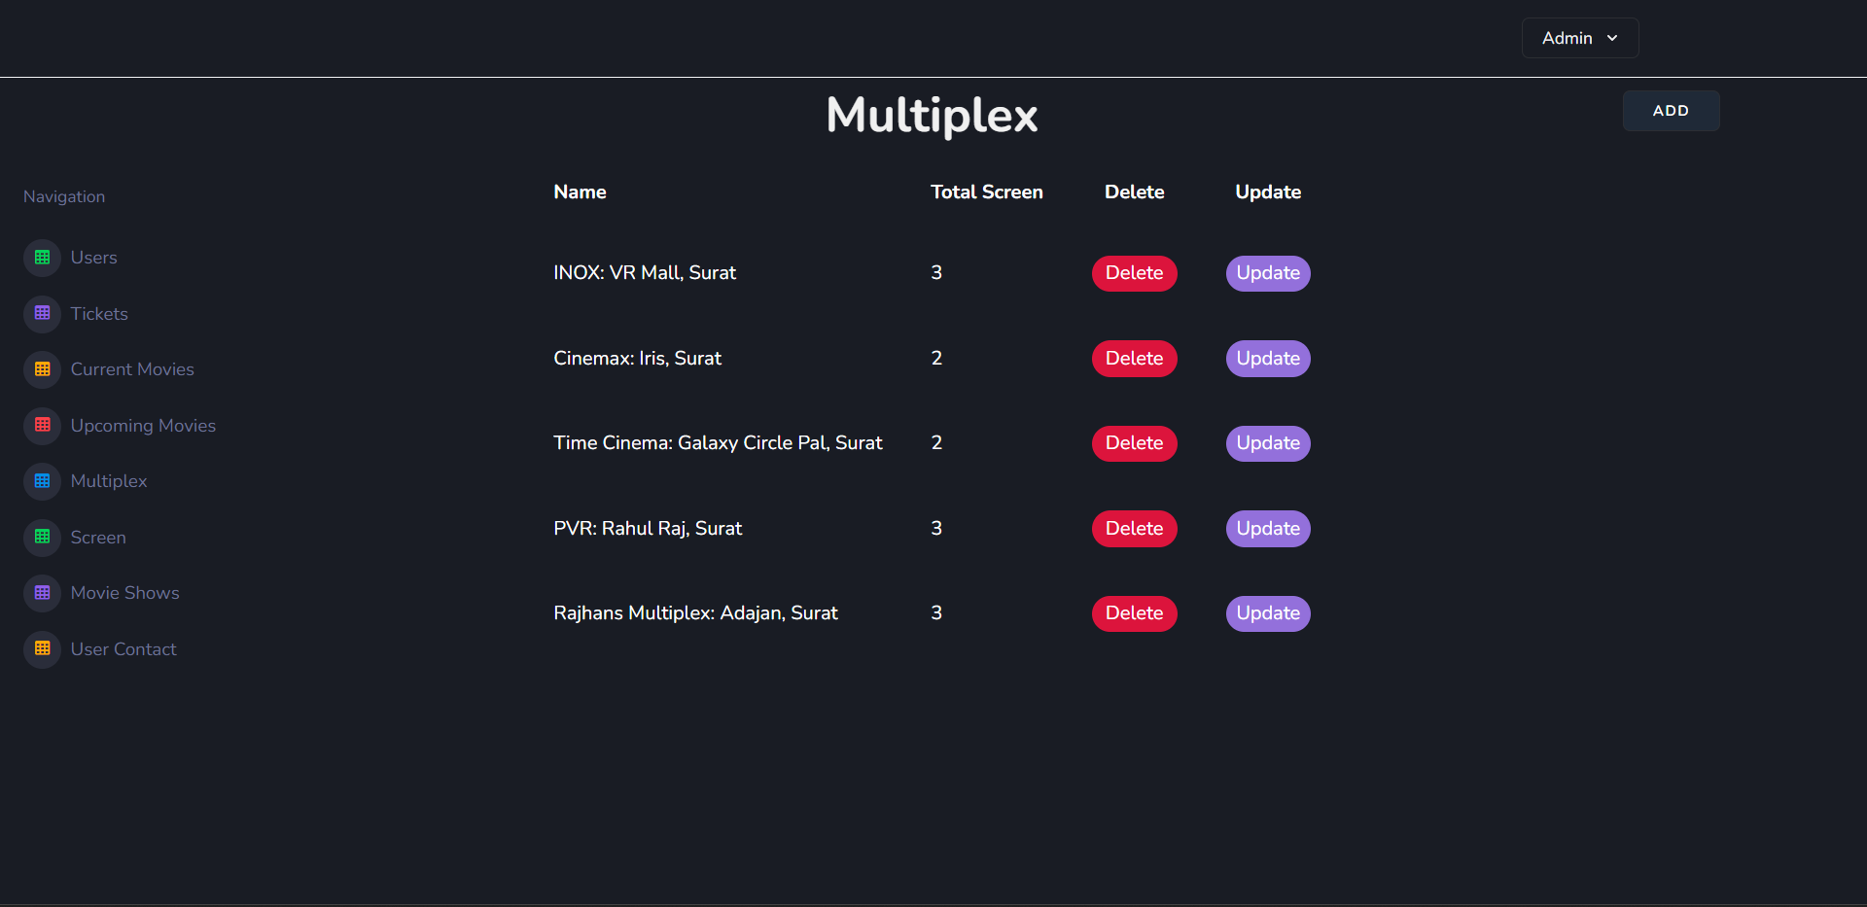

**Delete Multiplex :-**

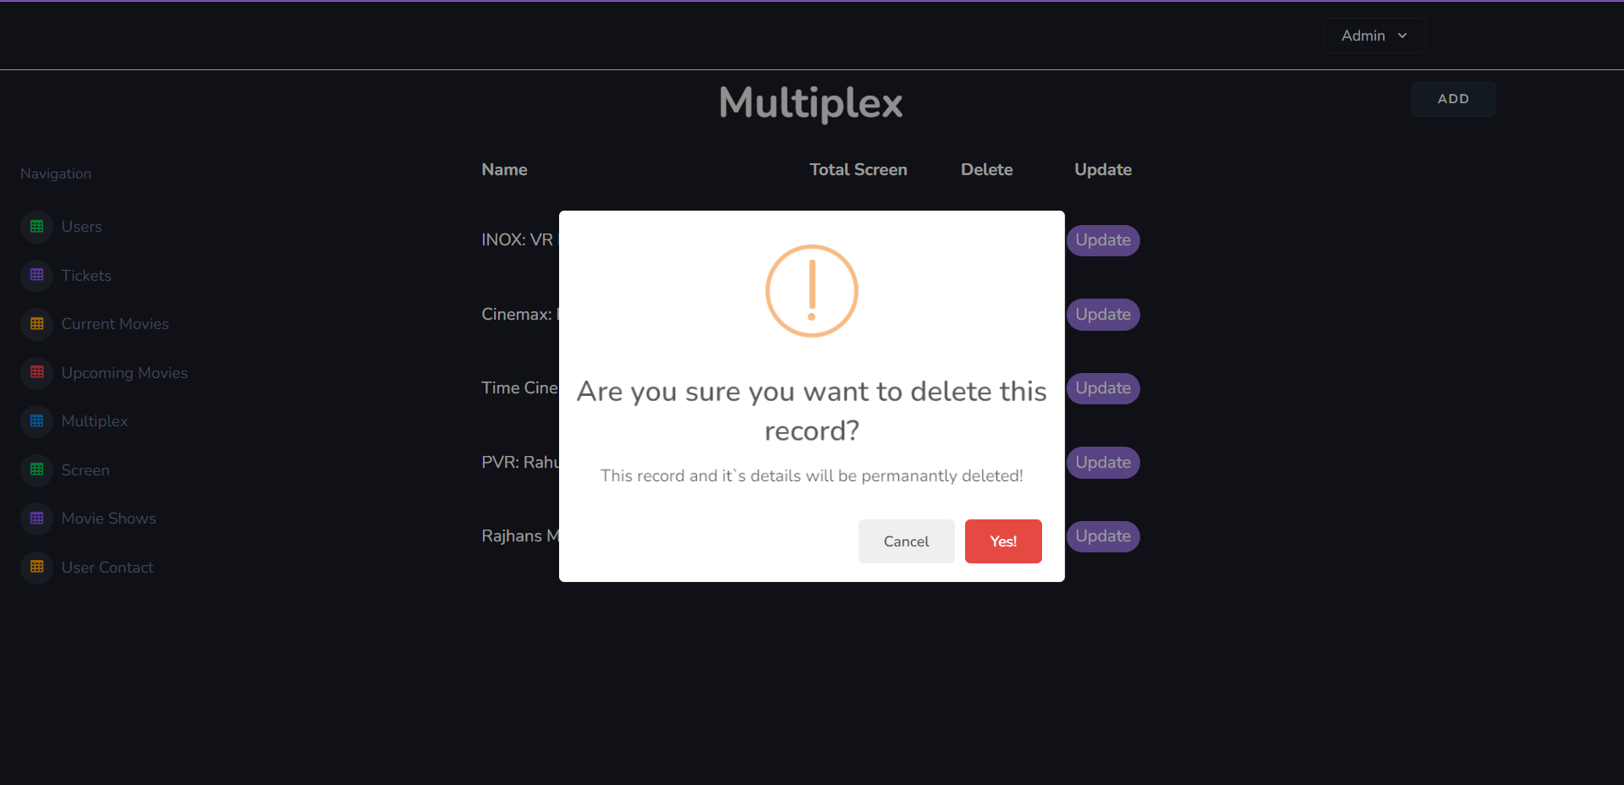

**Add Multiplex :-**

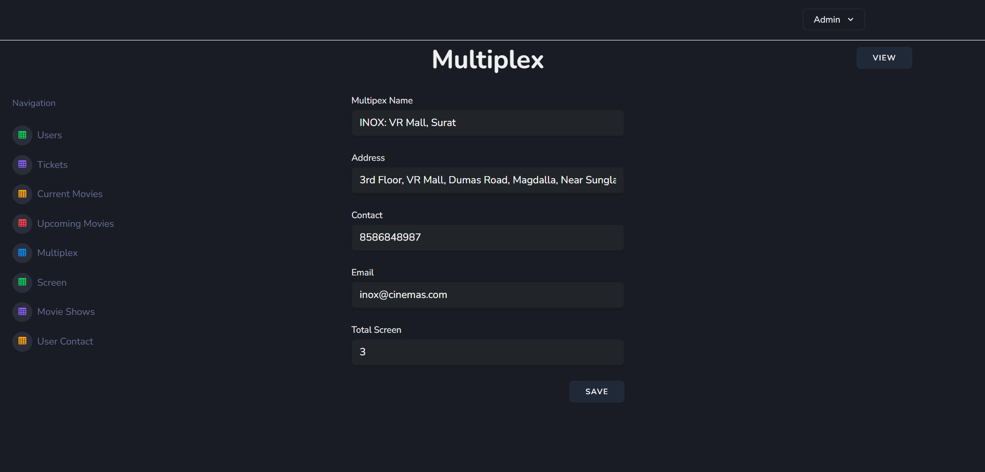

**Update Multiplex :-**

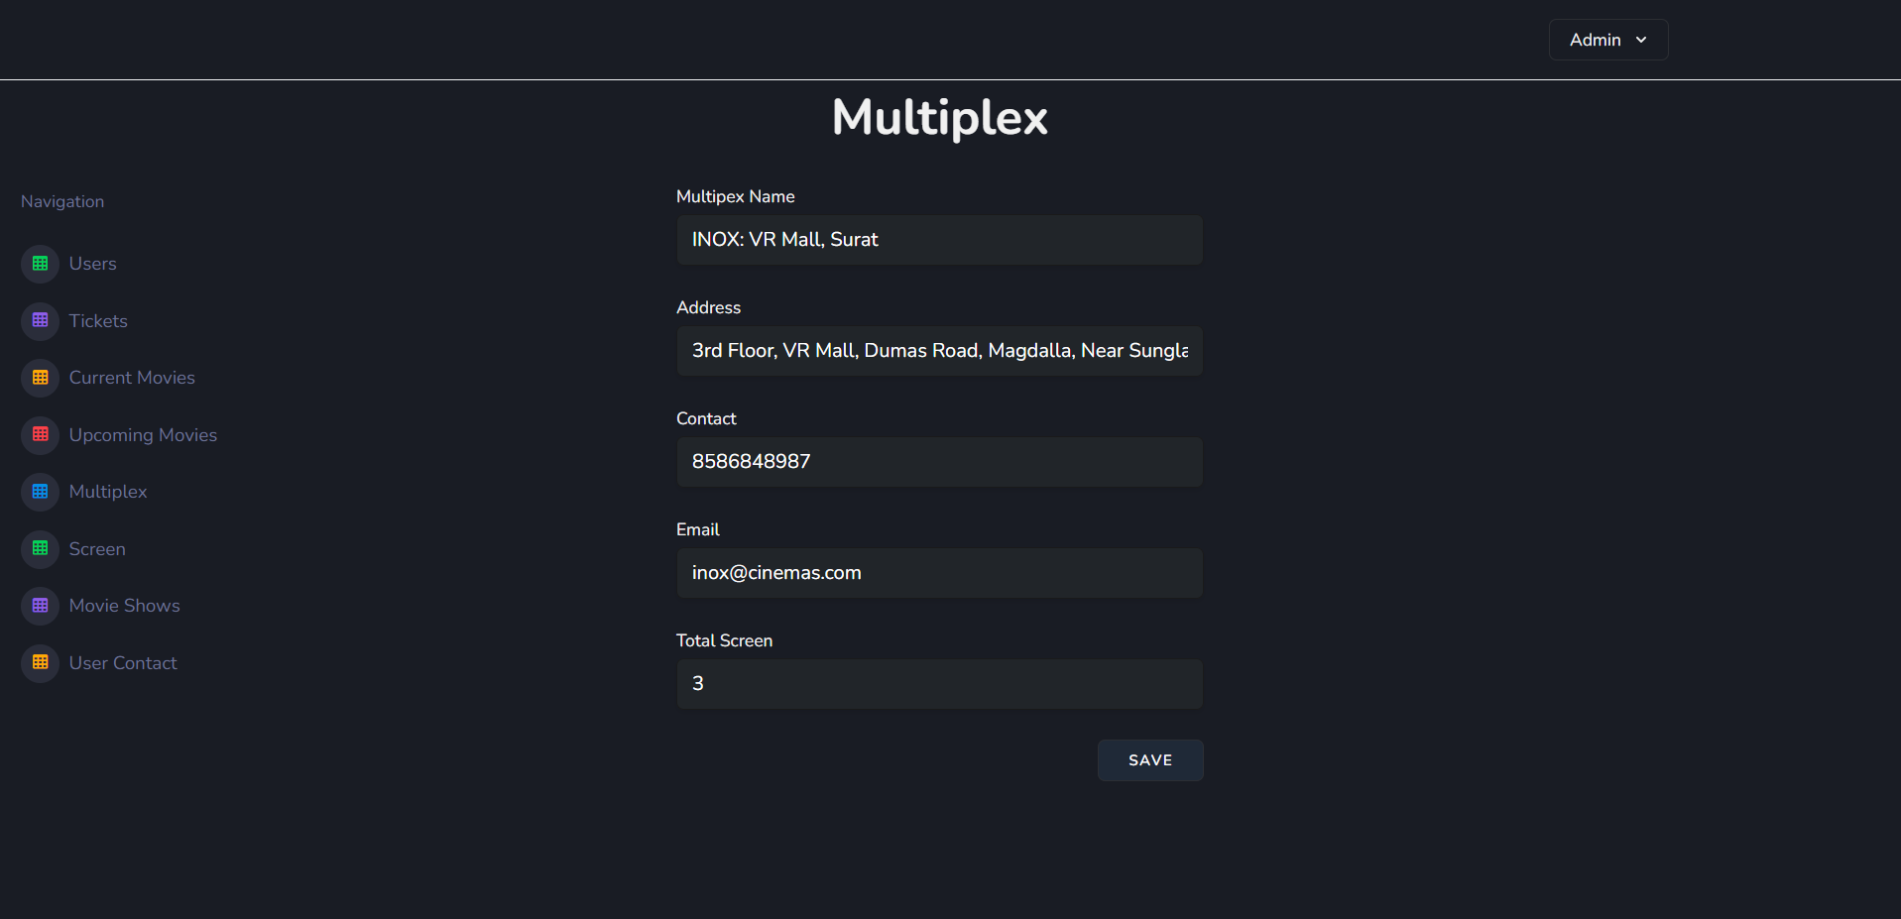

**Screen :-**

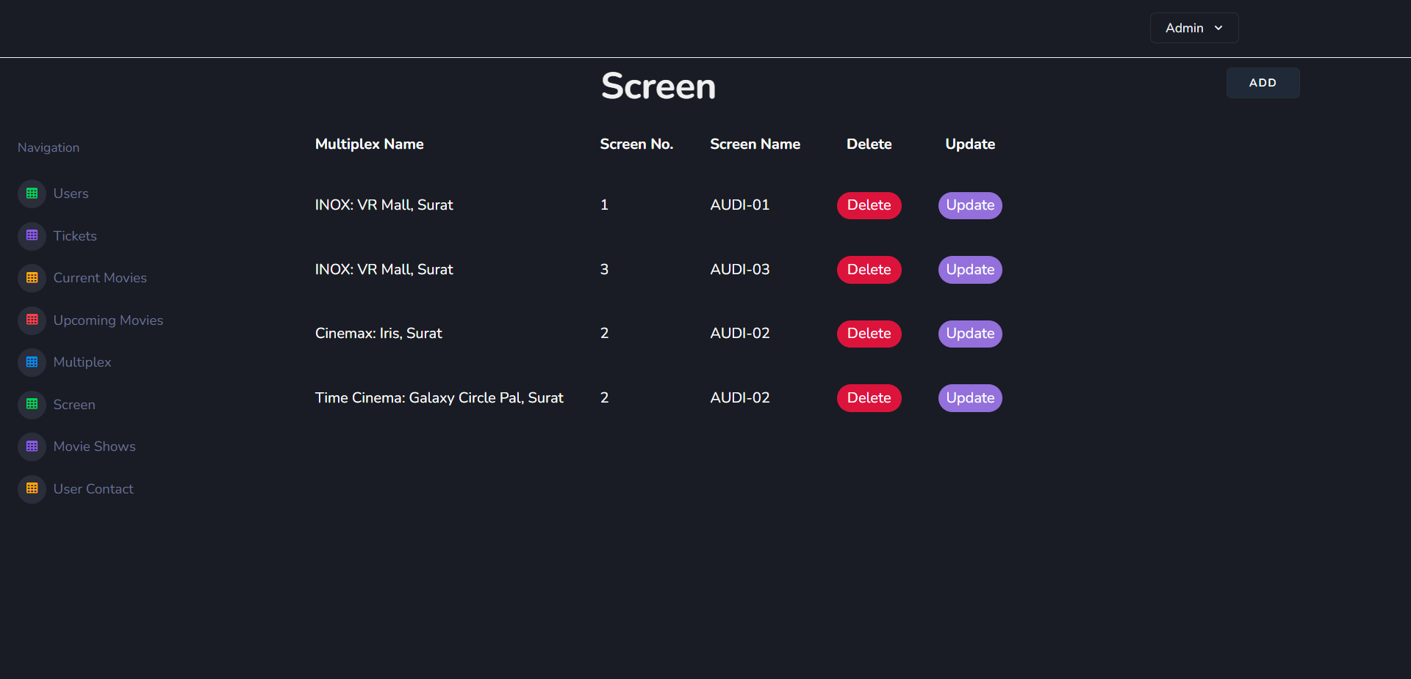

**Delete Screen :-**

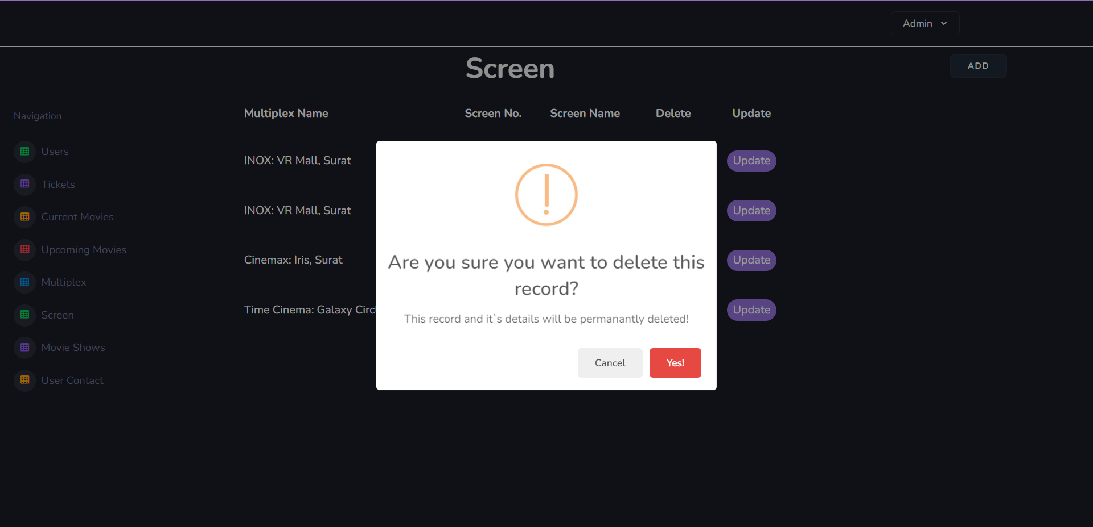

**Add Screen :-**

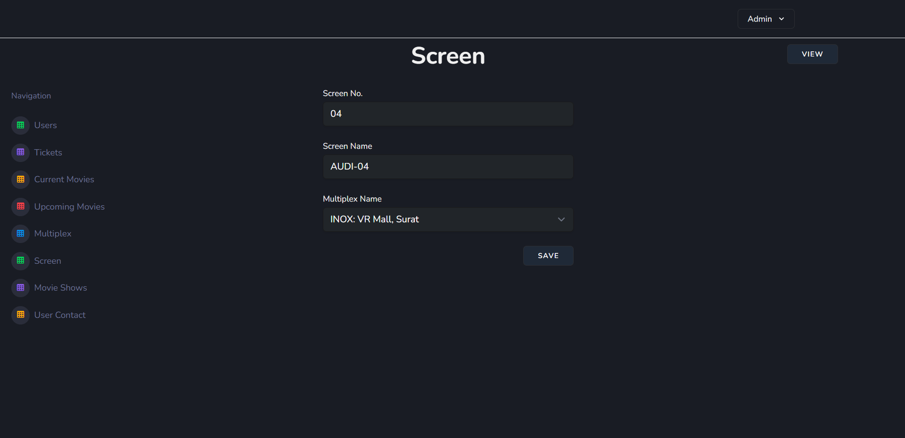

**Update Screen :-**

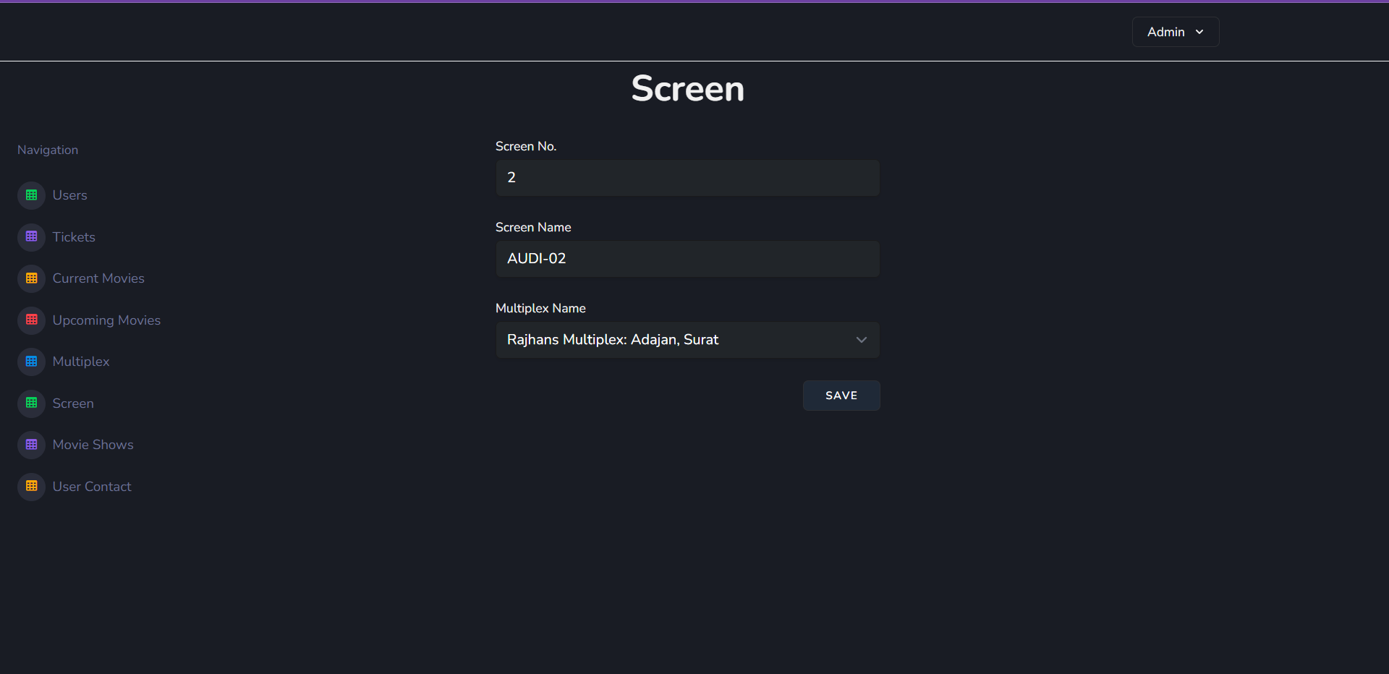

**Movie Shows :-**

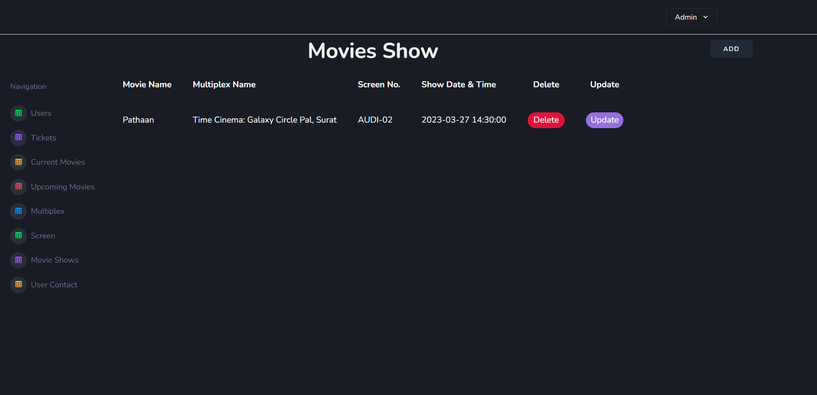

**Delete Movie Shows :-**

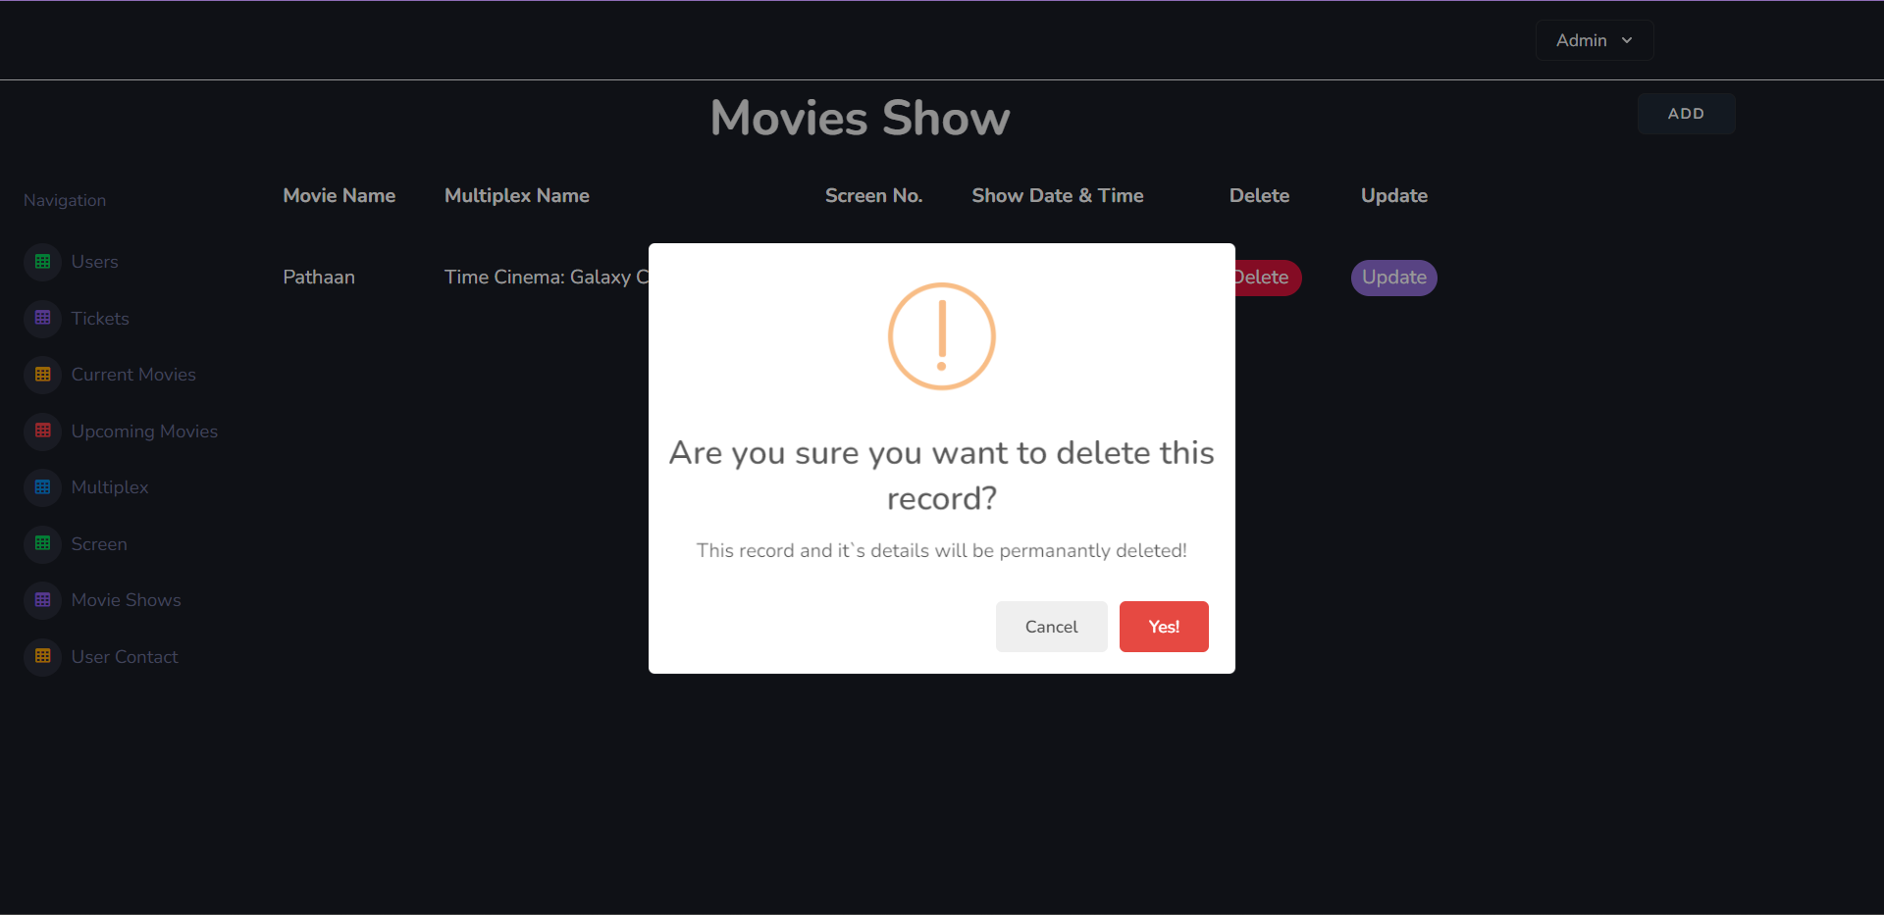

**Add Movie Shows :-**

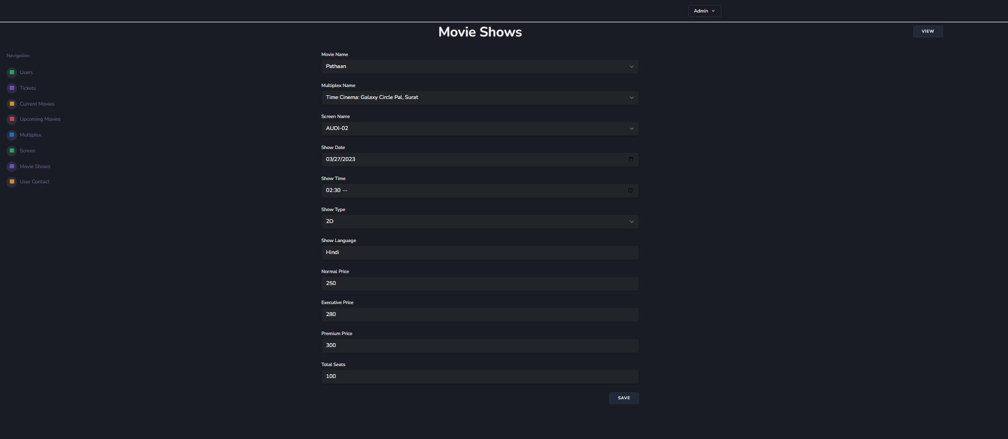

**Update Movie Shows :-**

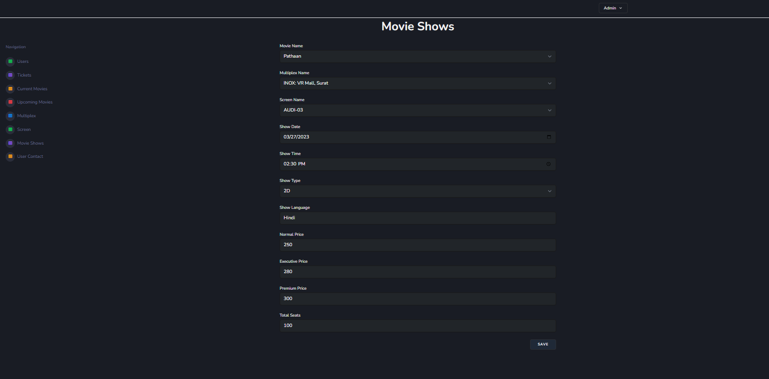

**User Contact :-**

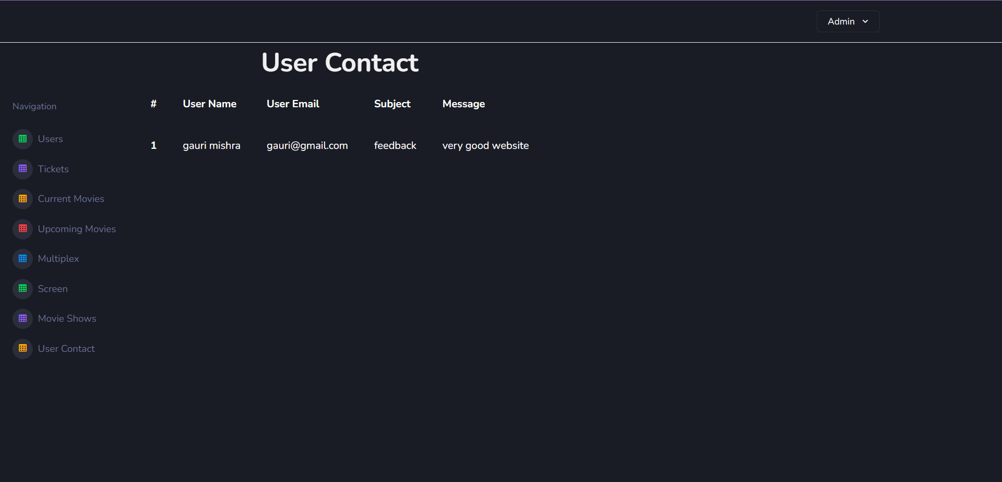

**8.2 User Panel**

**Login :-**

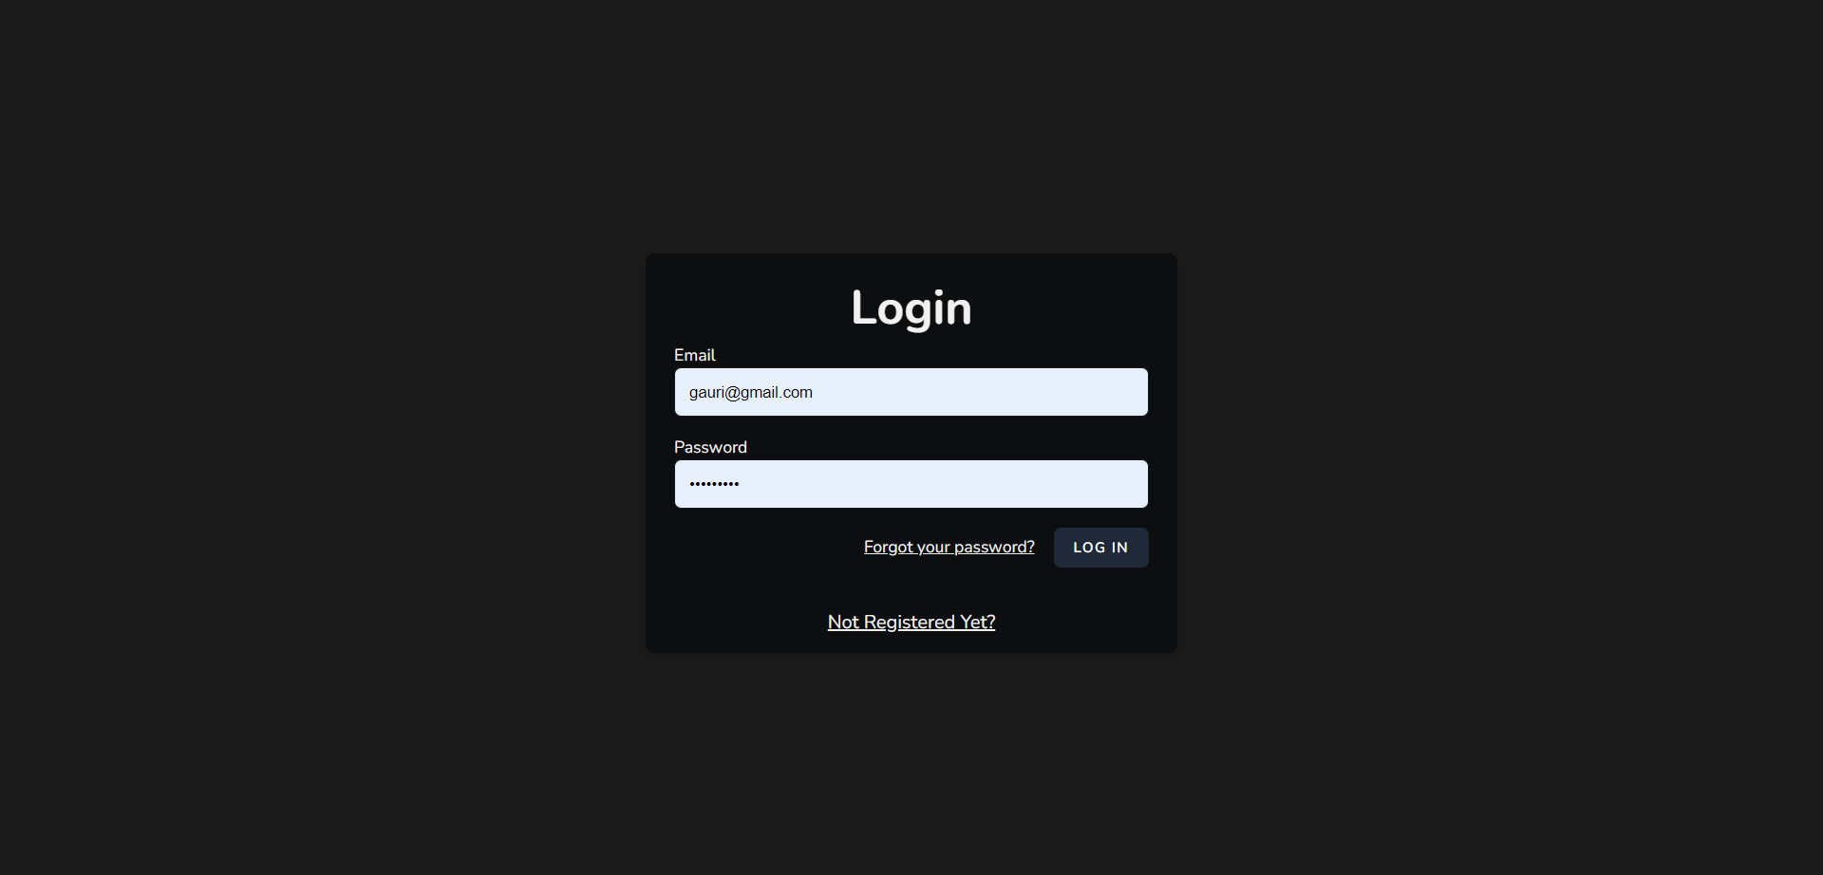

**Forgot Password :-**

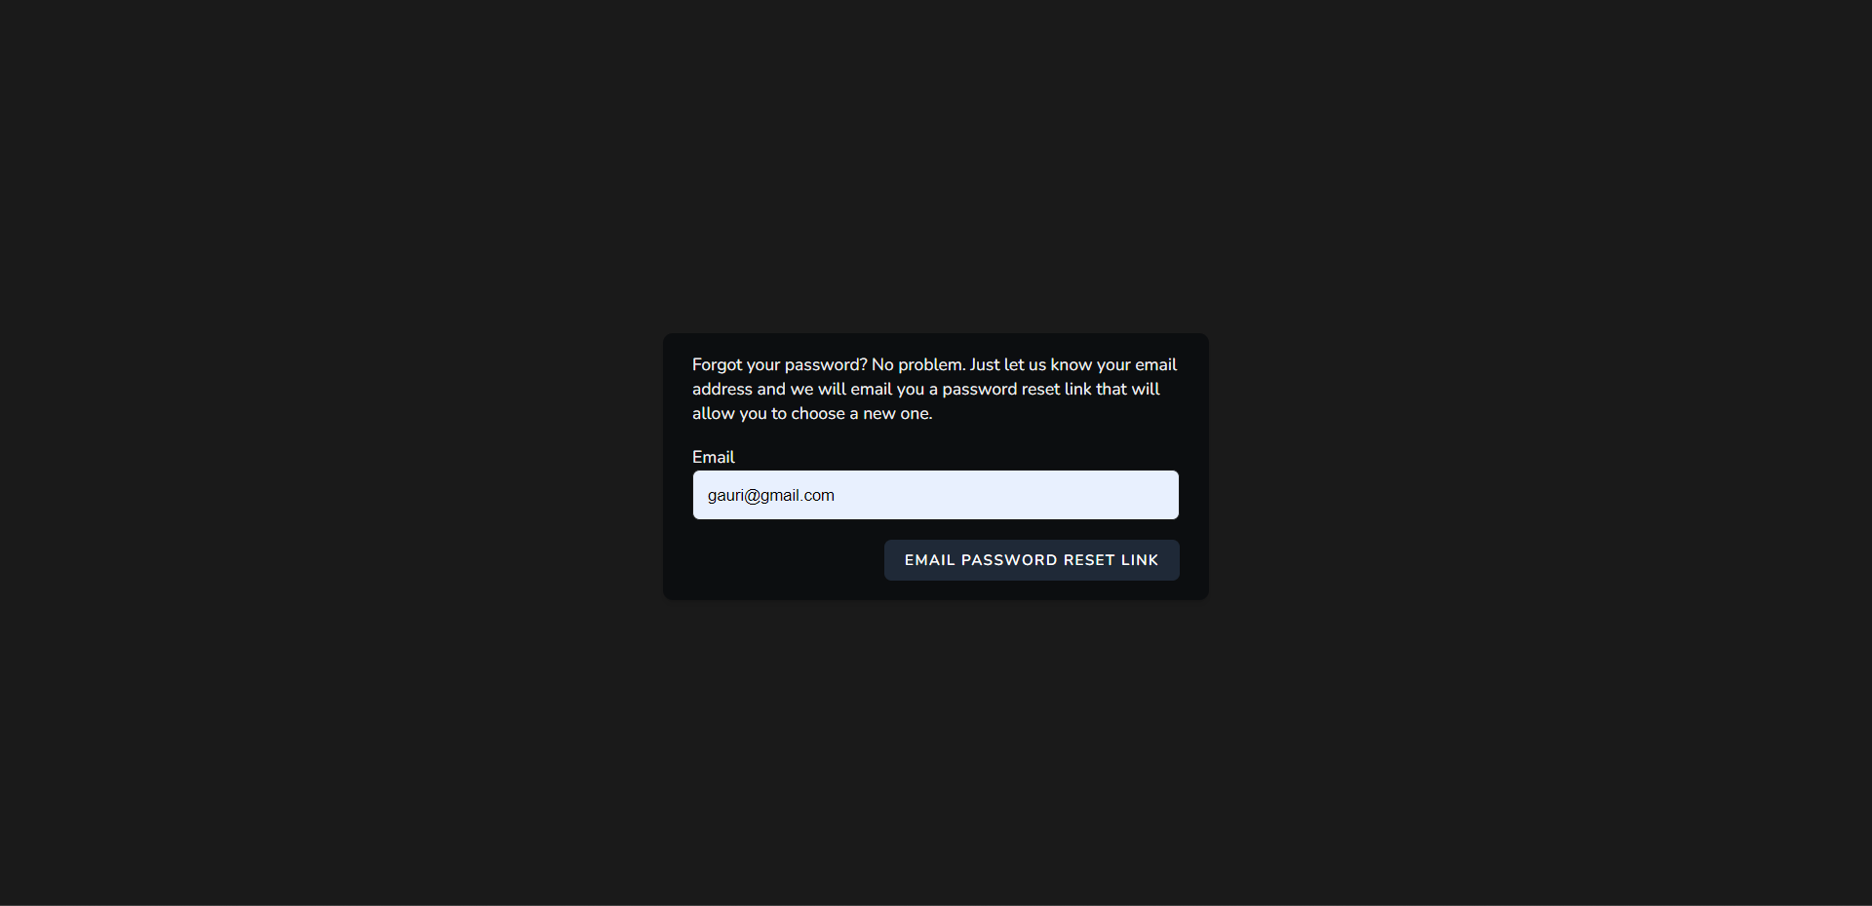

**Reset Password :-**

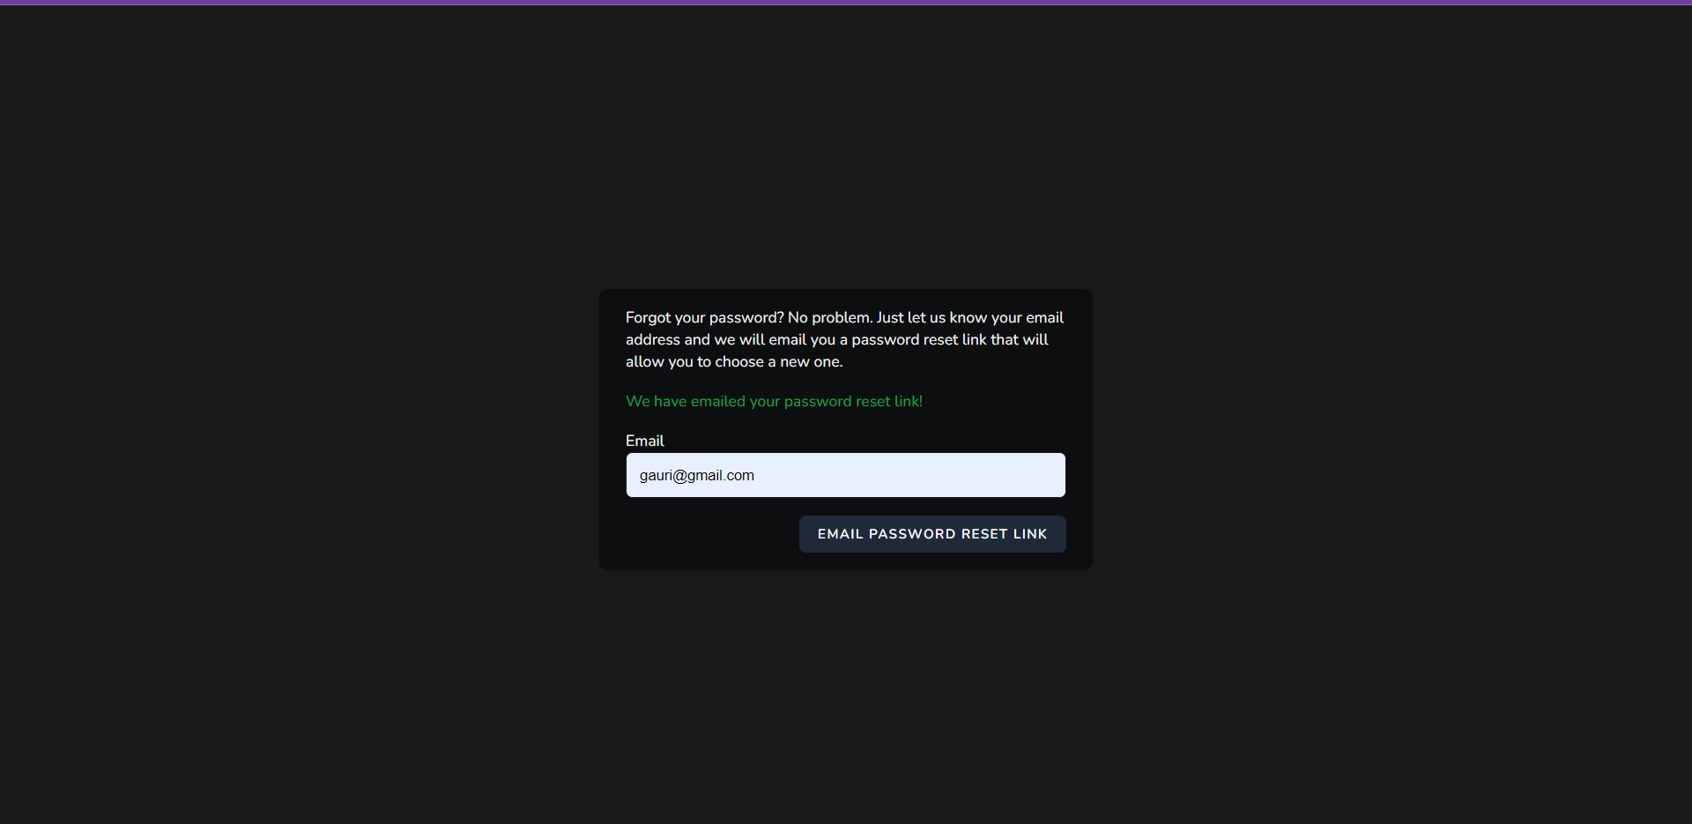

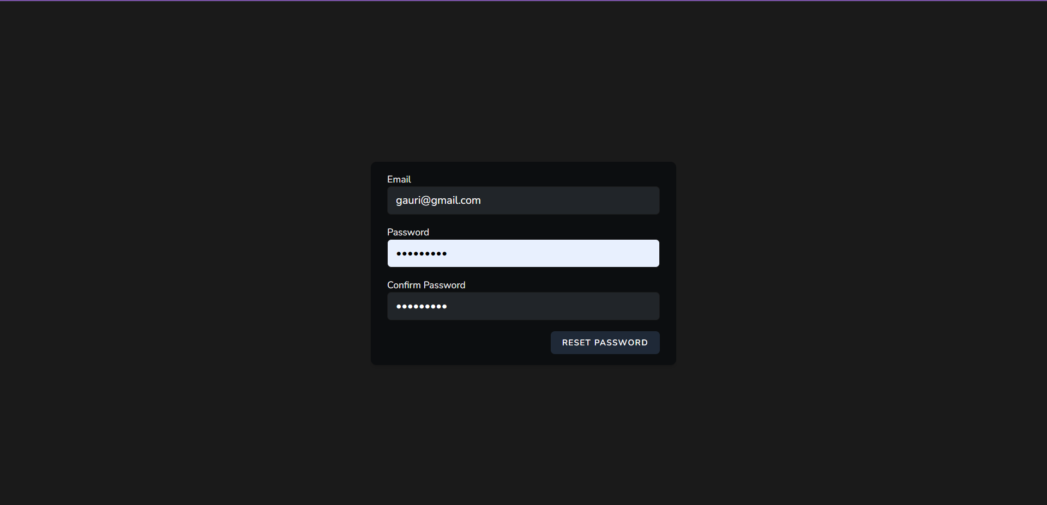

**Registration :-**

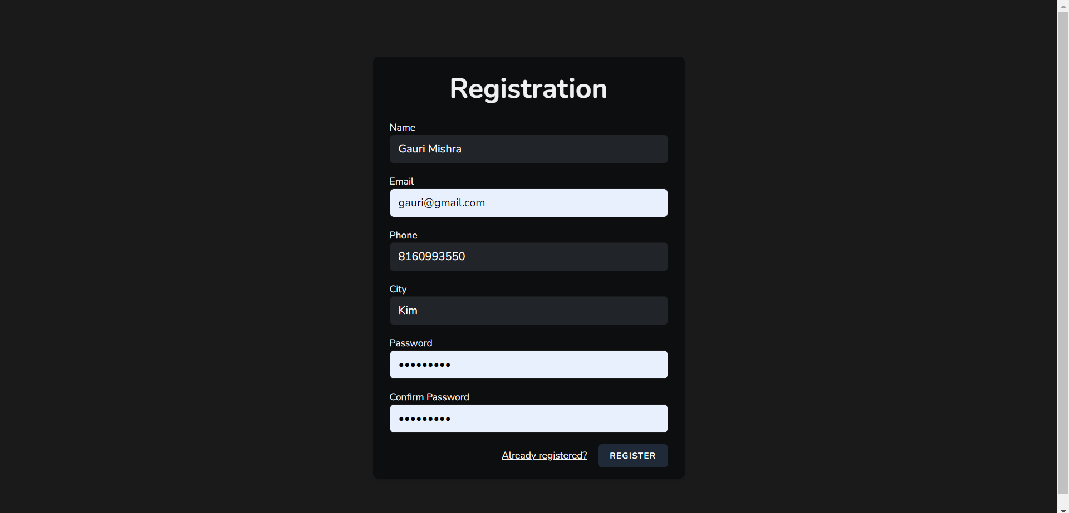

**Home :-**

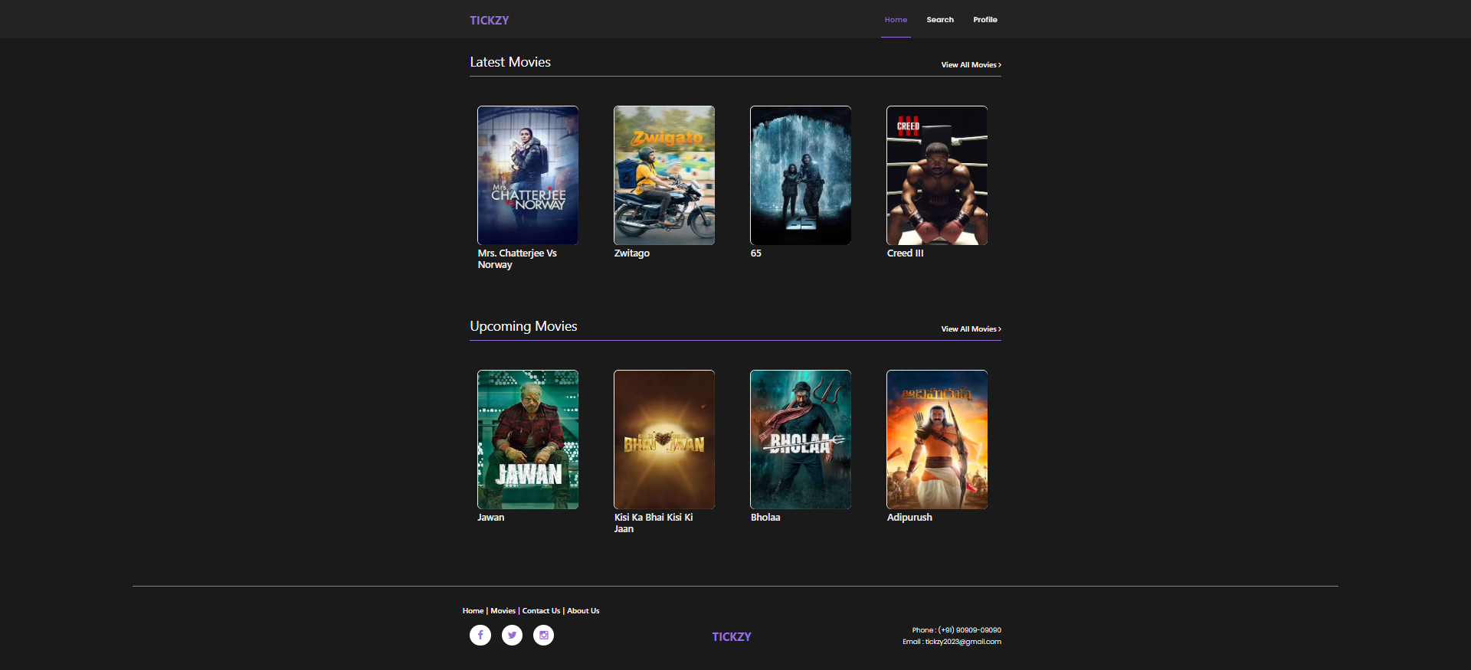

**Latest Movies :-**

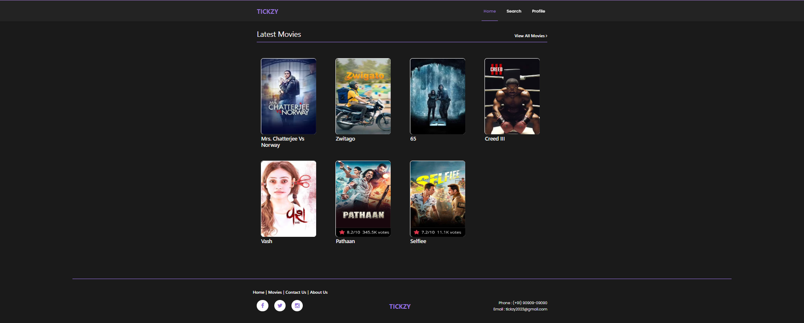

**Upcoming Movies :-**

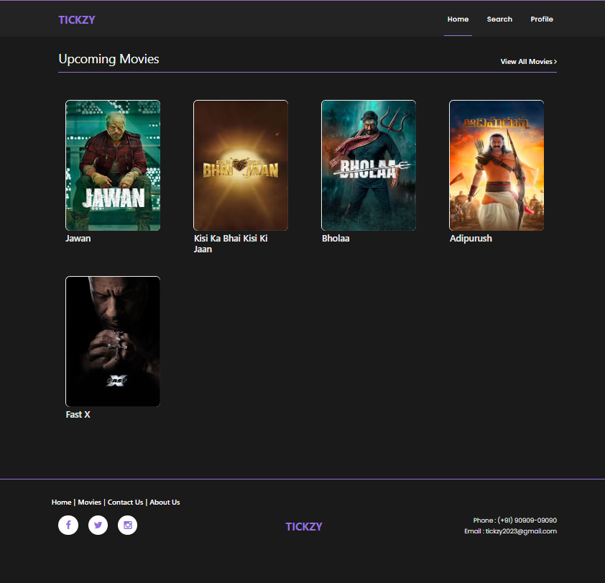

**Search :-**

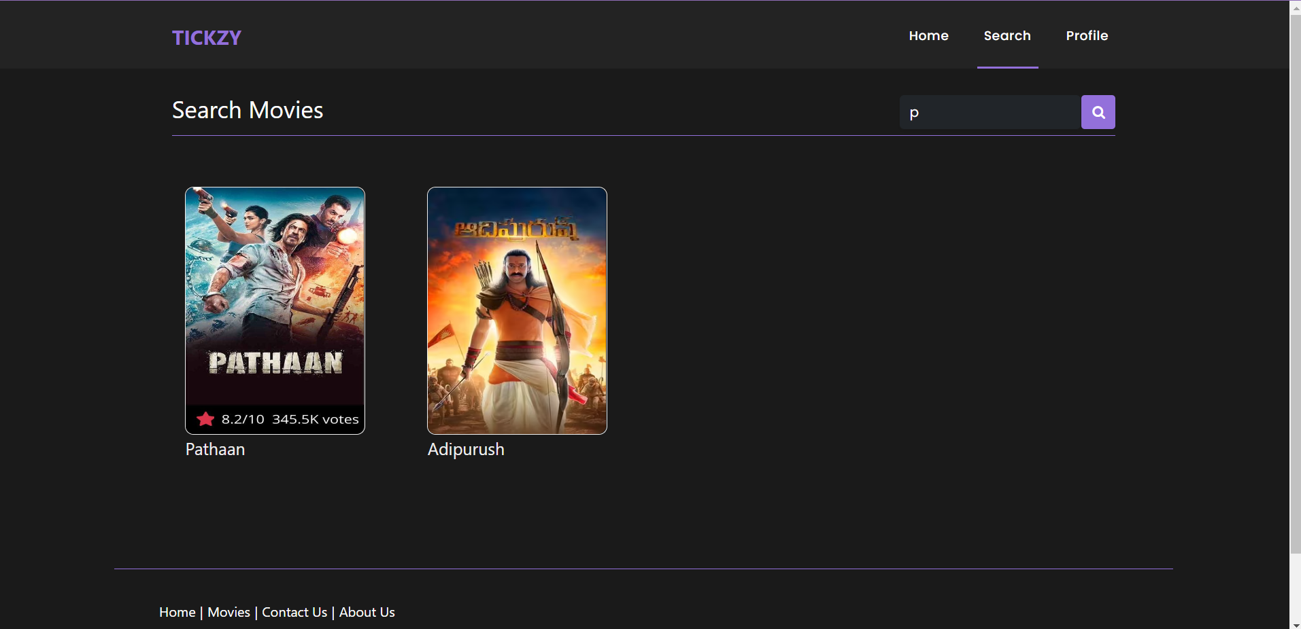

**Contact Us :-**

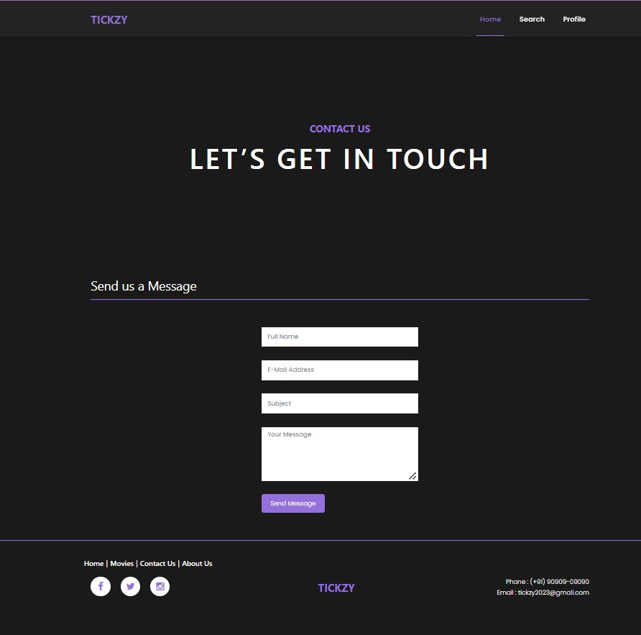

**Movie View :-**

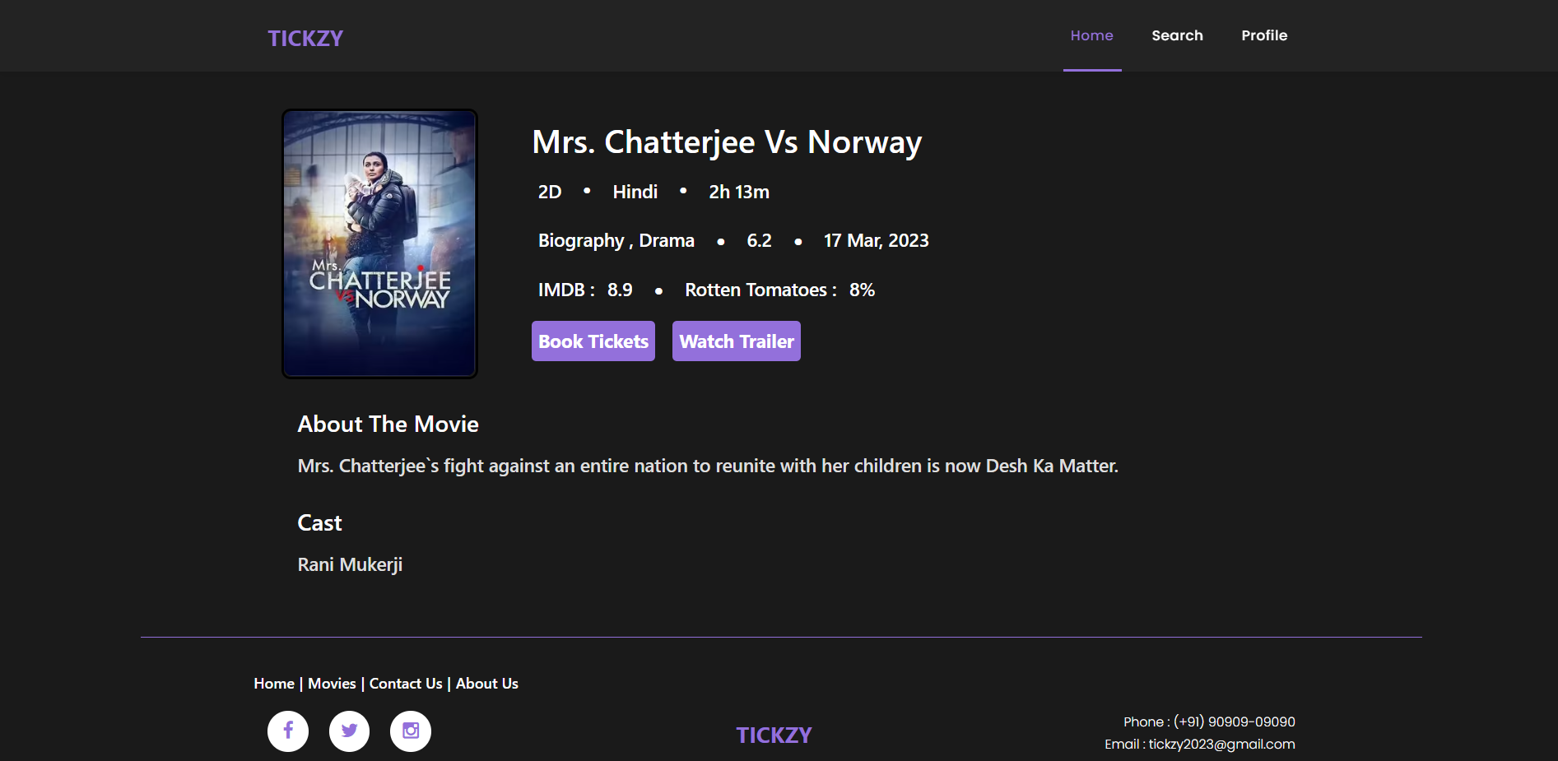

**Watch Trailer :-**

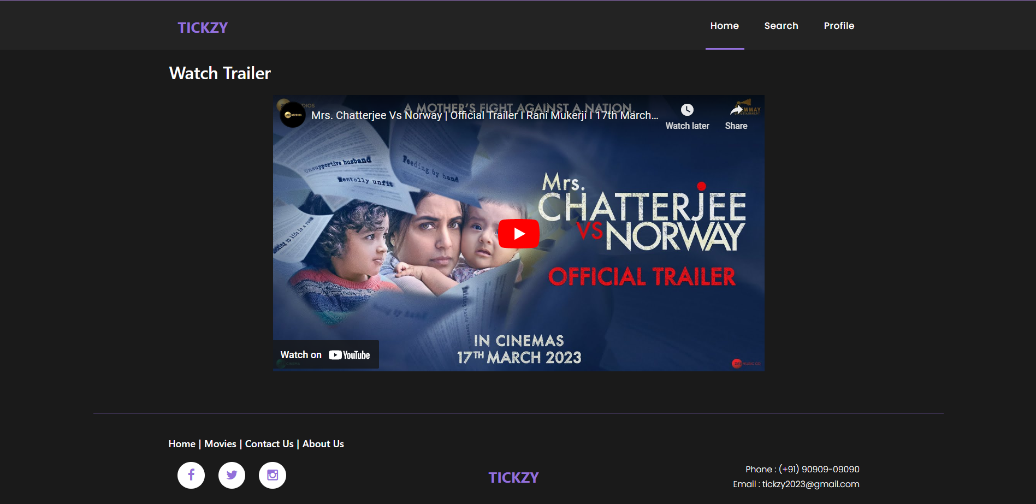

**Select Language :-**

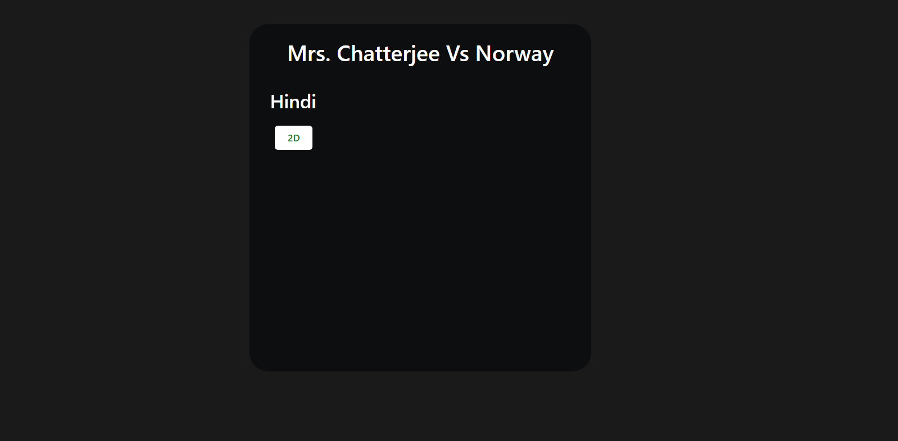

**Select Show By Date :-**

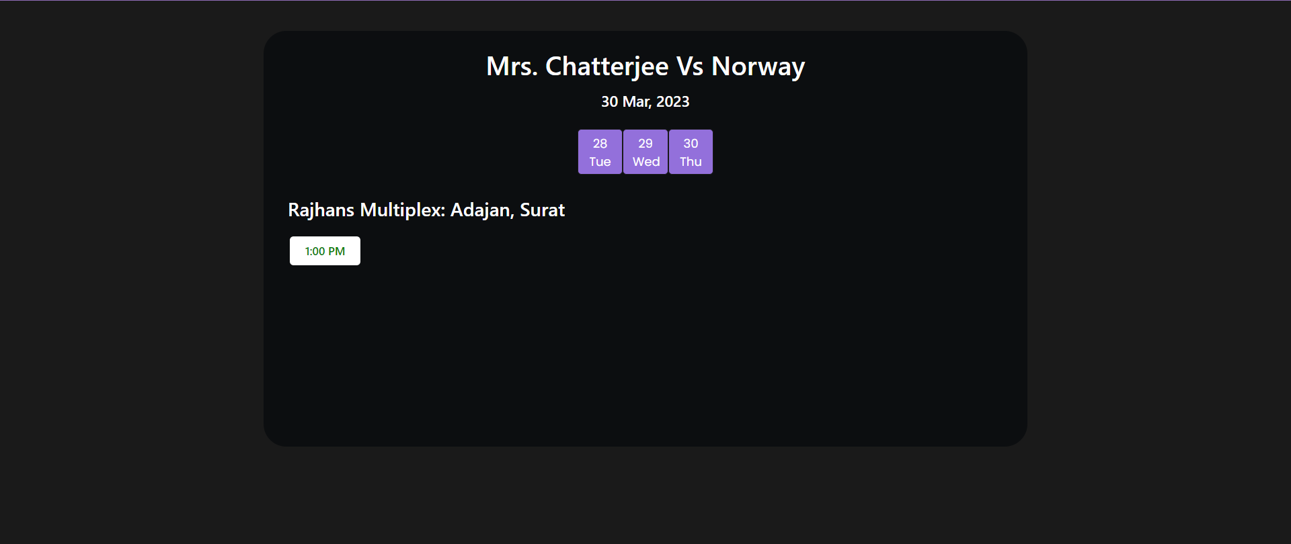

**Show Seats Availability :-**

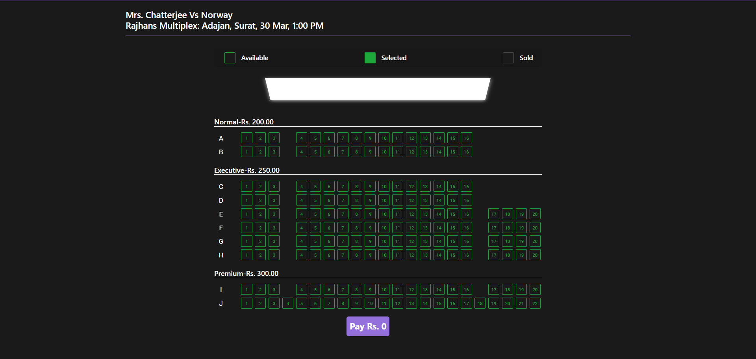

**Select Seats :-**

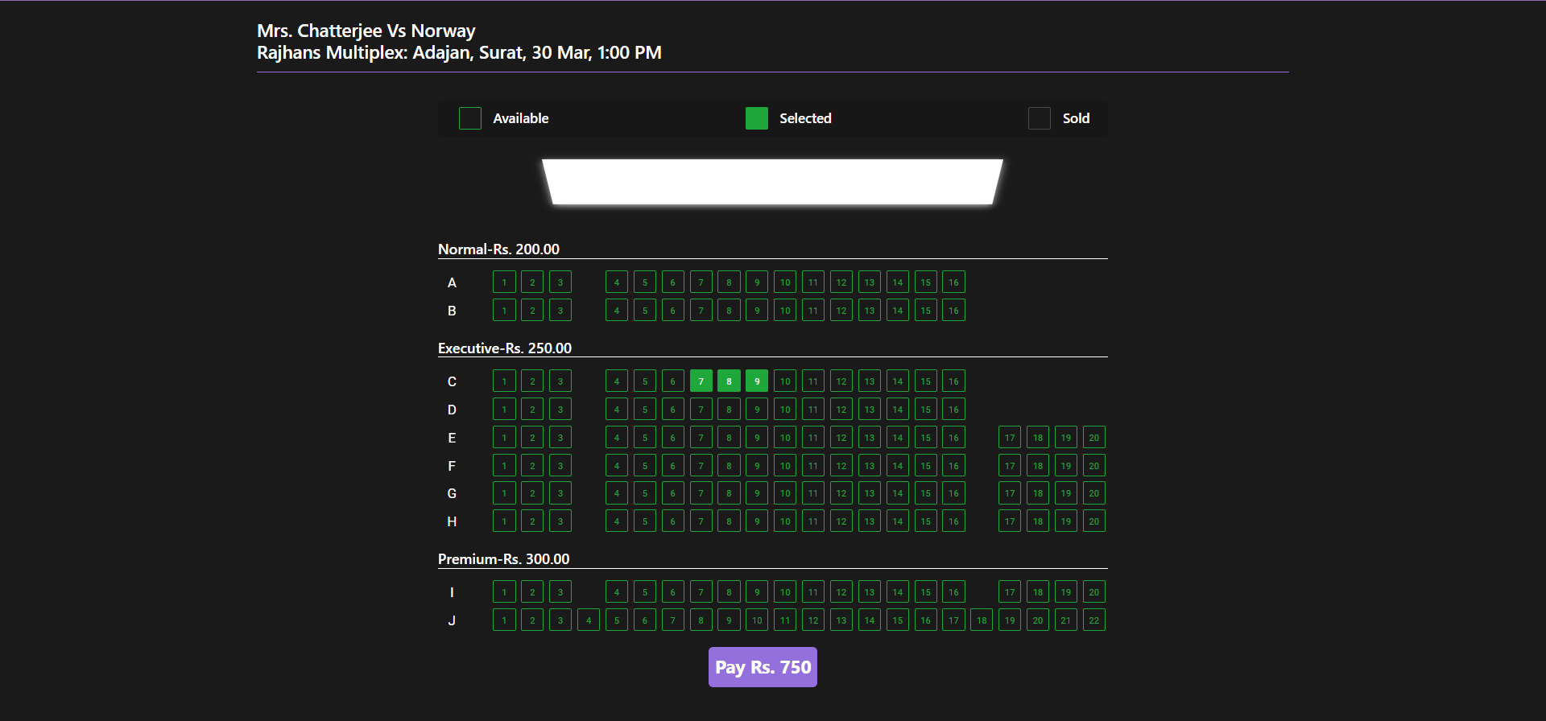

**Make Payment :-**

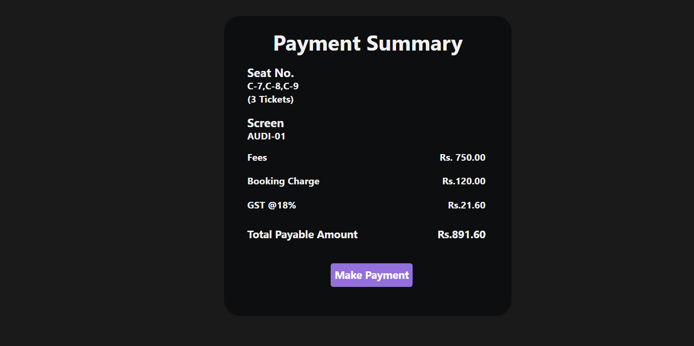

**Razorpay Payment :-**

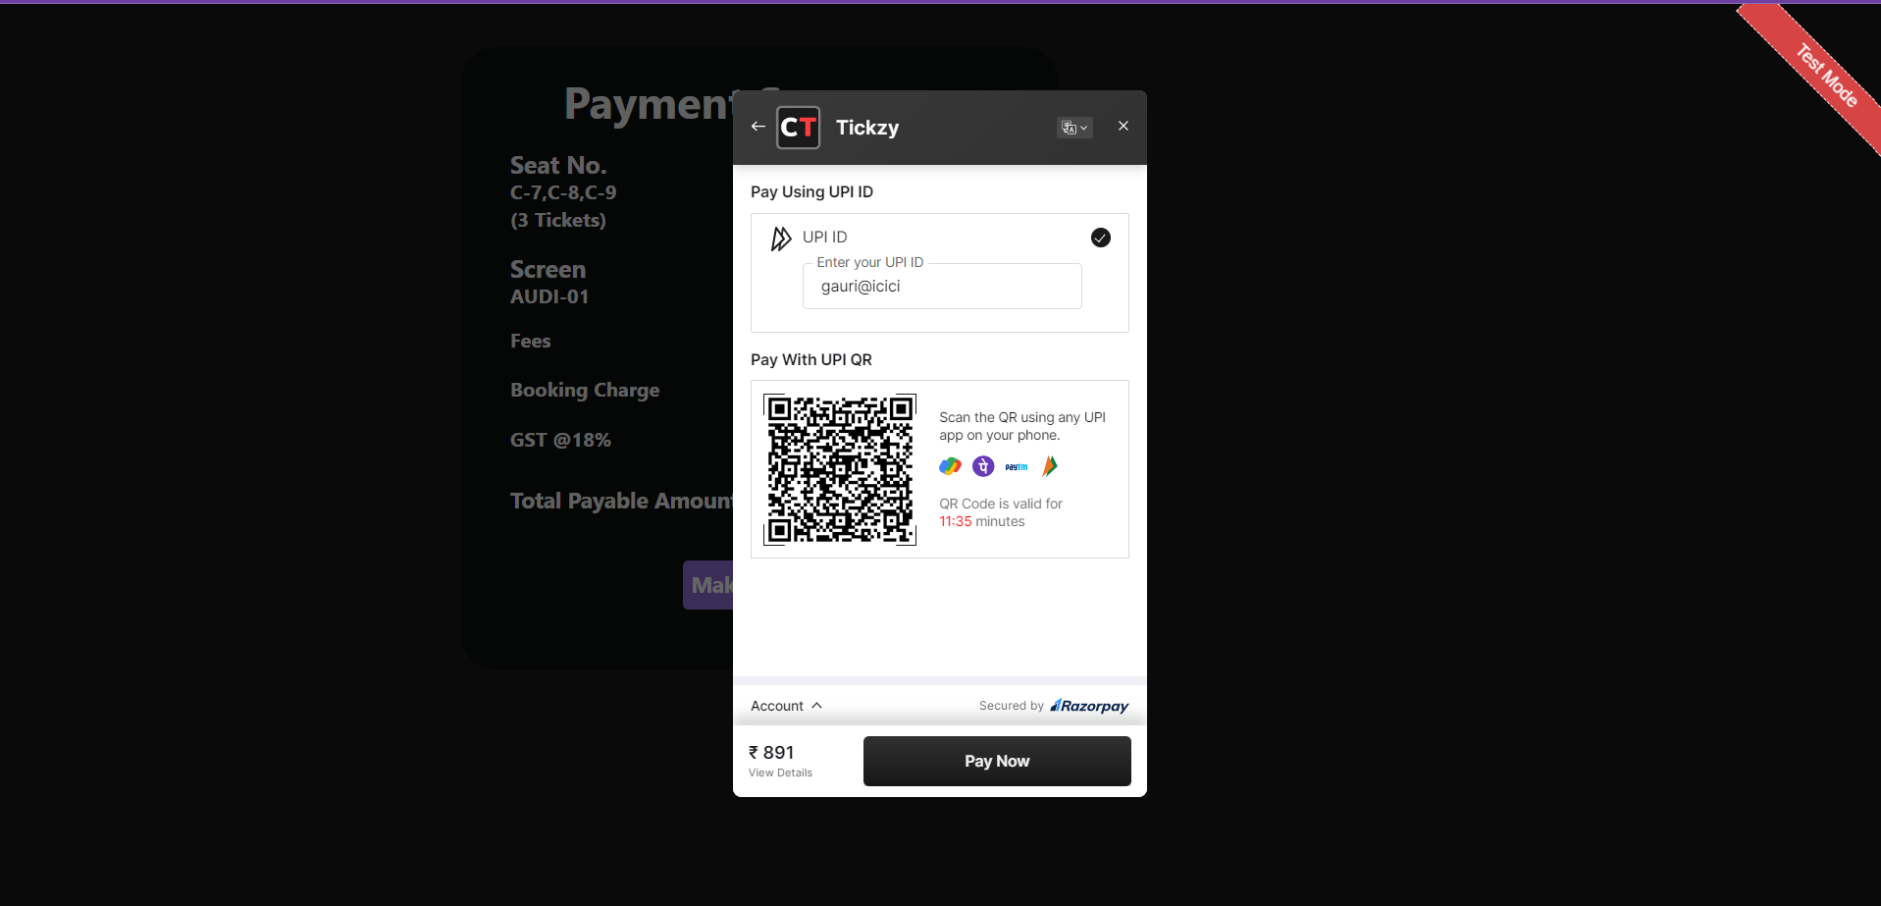

**Payment & Booking Successful :-**

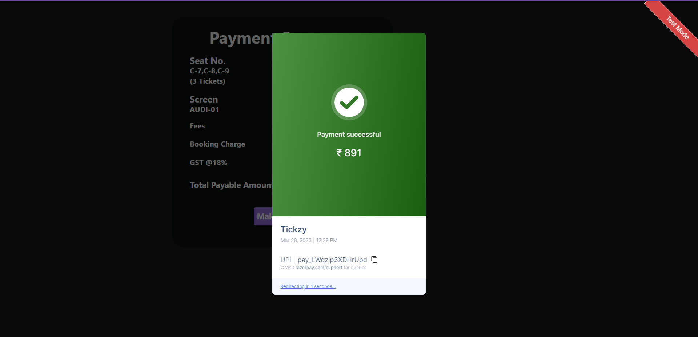

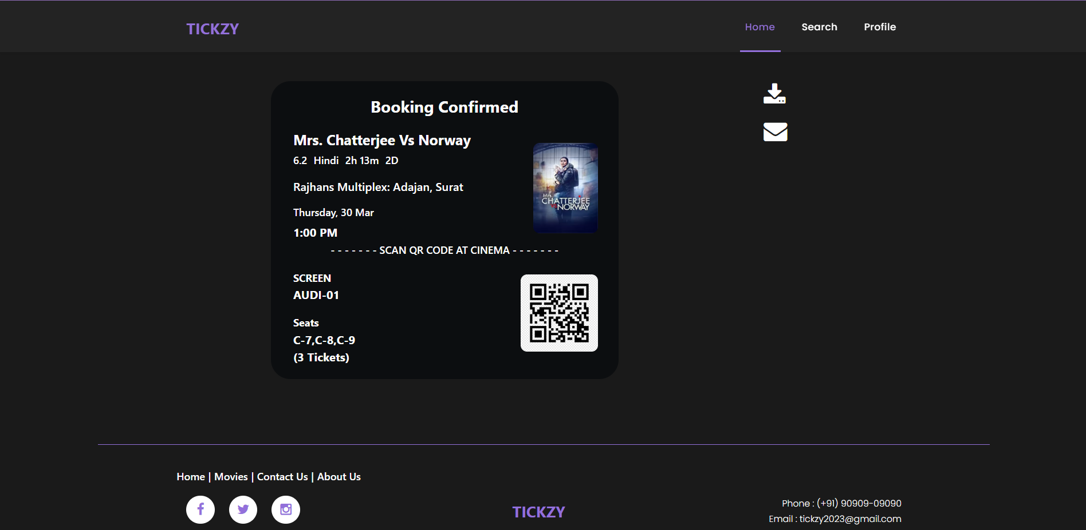

**User Profile :-**

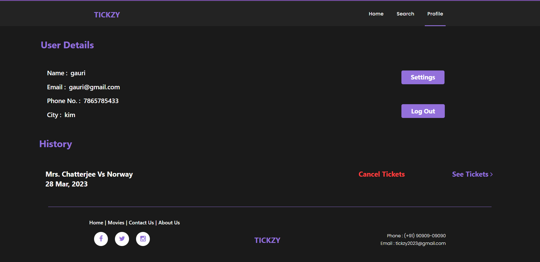

**Booking History :-**

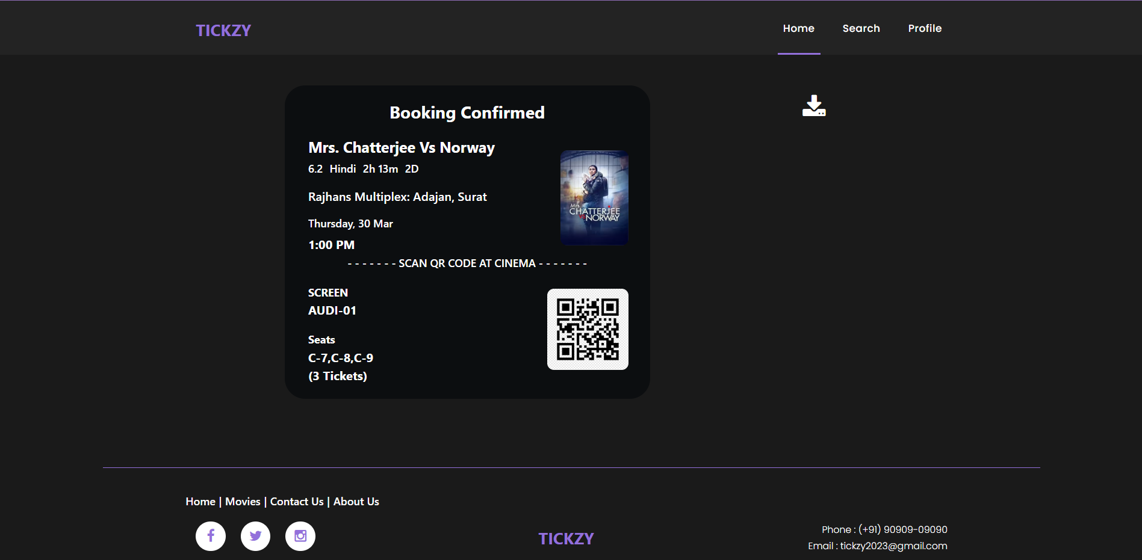

**Settings :-**

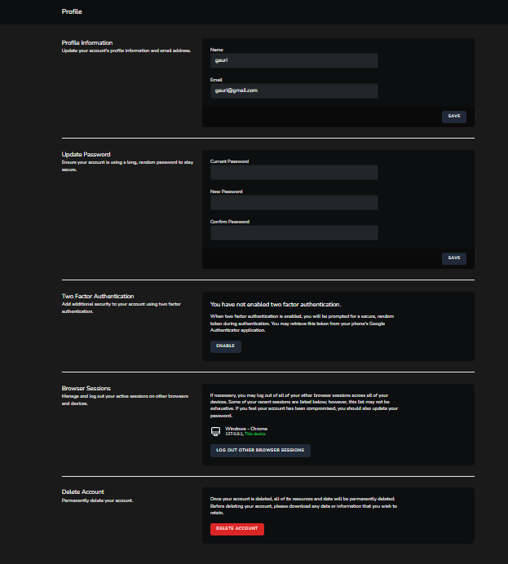

9. Testing



**9.1 Software Testing**

* Software testing is a critical element of software quality assurance and represents the ultimate review of specification design and coding. Testing is an exposure of a system to trial input to see whether it produces correct output.
* In our project, we had to test each unit to make sure it worked properly and there were no bugs.
* Testing finds errors, it does not correct errors. Software success is a quality of service, on time and within cost. Though testing can revel critical (costly) mistakes. Testing should therefore:
* Validate Performance.
* Detects Errors.
* Identify Inconsistencies.

**Test Objective**

* There is strong evidence that effective requirement management leads to overall project cost savings.
* The system presented here is titled as ―Movie Booking System. Various reports and data used for the same are the core of the system. The testing, therefore, becomes important in order to maintain the cost as well as improve performance and consistency.
* The output of one table is the input for other table. In the system, the movies are inserted into movies table, multiplex are inserted into multiplex table, screens are inserted into screens table and all this are transported to movie shows table.
* The testing procedure for the system has been divided in to various parts ranging for single unit testing to entire system testing.

**Test Planning**

* Test planning was actually to test all the individual modules and then to make the system work flawless and shouldn’t create any minor bugs and errors.

**Generating Test Cases**

* A test case is a unit of testing activity. Test cases have three parts:
* The aspect of the system being tested.
* Input and System State data provided to the system under stated conditions.
* Expected Behaviour the output or action the system should take according to these requirements.

**Test Case Selection**

* The presented system - Movie Booking System is tested using white-box testing which is based on the internal structure of the system, may also called as testing to code, path-oriented testing, or logical-driven testing. A common goal of white-box testing is to have a test case to exercise every path through a program. This may become exhaustive.

**White Box Testing Case Selection**

* Because exhaustive white-box testing is infeasible, test or code coverage metrics are used to select test cases, which measure the fraction of code exercised by test cases. Test cases are selected to achieve target test coverage levels.
* Test Coverage Metrics
* Statement Coverage: The fraction of statements executed at least once is running a collection of test cases.
* Branch Coverage: The fraction of total branch directions that have been taken at least once in running a collection of test cases.
* Path Coverage: The fraction of paths taken at least once in running a collection of test cases, where a path is defined in some way to limit the totals of feasible collection.

**9.2 Unit Testing**

* The presented system is tested first using unit testing. Unit testing is test of code written by a single programmer. A unit is a portion of a system implemented by a single programmer
* Unit testing is exercising a unit in isolation from the rest of the system. The system, then, is tested using Integrating Testing.

**9.3 System Testing**

* Top-Down: Combine, test and debug top-levelled routines that become the integration test that harms for lower-level units.
* Bottom-Up: Combine, test low-level routines into progressively larger modules and subsystems.
* Sandwich: Mainly top-down with bottom-up integration and testing applied to certain widely used components.

**Test Completion**

* White-box test coverage targets are met.
* Rate of error discovery reduced the target value.
* Measured reliability of the system achieves its target value.

**9.4 Test Cases**

**Test cases for Sign up module**

|  |  |  |  |  |  |  |
| --- | --- | --- | --- | --- | --- | --- |
| **Test**  **Case**  **ID** | **Field Name** | **Test Data** | **Valid/**  **Invalid** | **Expected Result** | **Actual Result** | **Pass/**  **Fail** |
| TSU-  01U | Name | Null | Invalid | Please fill out this field | As Expected | Pass |
|  |  | Gauri Mishra | Valid | - | As Expected | Pass |
| TSU-  02U | Email | Null | Invalid | Please fill out this field | As Expected | Pass |
|  |  | gauri@ | Invalid | Please enter a following ‘@’. ‘gauri@’ is incomplete | As Expected | Pass |
|  |  | gauri@gmail.  com | Valid | - | As Expected | Pass |
| TSU-  03U | Phone | Null | Invalid | Please fill out this field | As Expected | Pass |
|  |  | 8160993550 | Valid | - | As Expected | Pass |
| TSU-  04U | City | Null | Invalid | Please fill out this field | As Expected | Pass |
|  |  | Kim | Valid | City is Valid | As Expected | Pass |
| TSU-  05U | Password | Null | Invalid | Please fill out this field | As Expected | Pass |
|  |  | 12345678 | Valid | - | As Expected | Pass |
| TSU-  06U | Confirm Password | Null | Invalid | Please fill out this field | As Expected | Pass |
|  |  | 12345678 | Valid | - | As Expected | Pass |

**Test cases for Login module**

|  |  |  |  |  |  |  |
| --- | --- | --- | --- | --- | --- | --- |
| **Test**  **Case**  **ID** | **Field Name** | **Test Data** | **Valid/**  **Invalid** | **Expected Result** | **Actual Result** | **Pass/**  **Fail** |
| TLI-  01U | Email | Null | Invalid | Please fill out this field | As Expected | Pass |
|  |  | gauri@ | Invalid | Please enter a following ‘@’. ‘gauri@’ is incomplete | As Expected | Pass |
|  |  | gauri@gmail.com | Valid | - | As Expected | Pass |
| TLI-  02U | Password | Null | Invalid | Please fill out this field | As Expected | Pass |
|  |  | 12345678 | Valid | - | As Expected | Pass |

**Test cases for Settings module**

|  |  |  |  |  |  |  |
| --- | --- | --- | --- | --- | --- | --- |
| **Test**  **Case**  **ID** | **Field Name** | **Test Data** | **Valid/**  **Invalid** | **Expected Result** | **Actual Result** | **Pass/**  **Fail** |
| TSE-  01U | Name | Null | Invalid | Please fill out this field | As Expected | Pass |
|  |  | Gauri Mishra | Valid | - | As Expected | Pass |
| TSE-  02U | Email | Null | Invalid | Please fill out this field | As Expected | Pass |
|  |  | gauri@gmail.  Com | Valid | - | As Expected | Pass |

**Test cases for Upload Current movies**

|  |  |  |  |  |  |  |
| --- | --- | --- | --- | --- | --- | --- |
| **Test**  **Case**  **ID** | **Field Name** | **Test Data** | **Valid/**  **Invalid** | **Expected Result** | **Actual Result** | **Pass/**  **Fail** |
| TUC-  01C | Movie Name | Null | Invalid | Please fill out this field | As Expected | Pass |
|  |  | Selfiee | Valid | - | As Expected | Pass |
| TUC-  02C | Description | Null | Invalid | Please fill out this field | As Expected | Pass |
|  |  | A Bollywood superstar’s feud with an RTO officer gets played out in front of the entire country. | Valid | - | As Expected | Pass |
| TUC-  03C | Release Date | Null | Invalid | Please fill out this field | As Expected | Pass |
|  |  | 24-02-2023 | Valid | - | As Expected | Pass |
| TUC-  04C | Genre | Null | Invalid | Please fill out this field | As Expected | Pass |
|  |  | Drama,Action,Comedy | Valid | - | As Expected | Pass |
| TUC-  05C | Type | Null | Invalid | Please fill out this field | As Expected | Pass |
|  |  | 2D | Valid | - | As Expected | Pass |
| TUC-  06C | Length | Null | Invalid | Please fill out this field | As Expected | Pass |
|  |  | 2h 23m | Valid | - | As Expected | Pass |
| TUC-  07C | Trailer Link | Null | Invalid | Please fill out this field | As Expected | Pass |
|  |  | https://www.youtube.com/embed/lS1KScfdr70 | Valid | - | As Expected | Pass |
| TUC-  08C | slug | Null | Invalid | Please fill out this field | As Expected | Pass |
|  |  | selfiee | Valid | - | As Expected | Pass |
| TUC-  09C | Rating | Null | Invalid | Please fill out this field | As Expected | Pass |
|  |  | UA | Valid | - | As Expected | Pass |
| TUC-  10C | Cast | Null | Invalid | Please fill out this field | As Expected | Pass |
|  |  | Akshay kumar , Emraan hashmi | Valid | - | As Expected | Pass |
| TUC-  11C | Languages | Null | Invalid | Please fill out this field | As Expected | Pass |
|  |  | Hindi | Valid | - | As Expected | Pass |
| TUC-  12C | IMDB Rating | Null | Invalid | Please fill out this field | As Expected | Pass |
|  |  | 8.5 | Valid | - | As Expected | Pass |
| TUC-  13U | Rotten Tomatoes | Null | Invalid | Please fill out this field | As Expected | Pass |
|  |  | 81 | Valid | - | As Expected | Pass |

**Test cases for Upload Upcoming movies**

|  |  |  |  |  |  |  |
| --- | --- | --- | --- | --- | --- | --- |
| **Test**  **Case**  **ID** | **Field Name** | **Test Data** | **Valid/**  **Invalid** | **Expected Result** | **Actual Result** | **Pass/**  **Fail** |
| TUU-  01U | Movie Name | Null | Invalid | Please fill out this field | As Expected | Pass |
|  |  | Fast X | Valid | - | As Expected | Pass |
| TUU-  02U | Description | Null | Invalid | Please fill out this field | As Expected | Pass |
|  |  | Dom Toretto and his family must confront a terrifying new enemy who`s fueled by revenge. | Valid | - | As Expected | Pass |
| TUU-  03U | Release Date | Null | Invalid | Please fill out this field | As Expected | Pass |
|  |  | 19-05-2023 | Valid | - | As Expected | Pass |
| TUU-  04U | Genre | Null | Invalid | Please fill out this field | As Expected | Pass |
|  |  | Action , Adventure , Crime , Thriller | Valid | - | As Expected | Pass |
| TUU-  05U | Type | Null | Invalid | Please fill out this field | As Expected | Pass |
|  |  | 2D,IMAX2D | Valid | - | As Expected | Pass |
| TUU-  06U | Trailer Link | Null | Invalid | Please fill out this field | As Expected | Pass |
|  |  | https://www.youtube.com/  embed/XdF7PkwJT1A | Valid | - | As Expected | Pass |
| TUU-  07U | Slug | Null | Invalid | Please fill out this field | As Expected | Pass |
|  |  | fast x | Valid | - | As Expected | Pass |
| TUU-  08U | Cast | Null | Invalid | Please fill out this field | As Expected | Pass |
|  |  | Vin diesel, Jason momoa, John cena | Valid | - | As Expected | Pass |
| TUU-  09U | Languages | Null | Invalid | Please fill out this field | As Expected | Pass |
|  |  | English, Hindi, Tamil, Telugu | Valid | - | As Expected | Pass |

**Test cases for Upload Multiplex**

|  |  |  |  |  |  |  |
| --- | --- | --- | --- | --- | --- | --- |
| **Test**  **Case**  **ID** | **Field Name** | **Test Data** | **Valid/**  **Invalid** | **Expected Result** | **Actual Result** | **Pass/**  **Fail** |
| TUM-  01M | Multiplex Name | Null | Invalid | Please fill out this field | As Expected | Pass |
|  |  | INOX: VR Mall, Surat | Valid | - | As Expected | Pass |
| TUM-  02M | Address | Null | Invalid | Please fill out this field | As Expected | Pass |
|  |  | 3rd Floor, VR Mall, Dumas Road, Magdalla, Near Sunglass Hut, Surat, Gujarat 395007, India | Valid | - | As Expected | Pass |
| TUM-  03M | Contact | Null | Invalid | Please fill out this field | As Expected | Pass |
|  |  | 8586848987 | Valid | - | As Expected | Pass |
| TUM-  04M | Email | Null | Invalid | Please fill out this field | As Expected | Pass |
|  |  | inox@cinemas.com | Valid | - | As Expected | Pass |
| TUM-  05M | Total Screen | Null | Invalid | Please fill out this field | As Expected | Pass |
|  |  | 3 | Valid | - | As Expected | Pass |

**Test cases for Upload Screen**

|  |  |  |  |  |  |  |
| --- | --- | --- | --- | --- | --- | --- |
| **Test**  **Case**  **ID** | **Field Name** | **Test Data** | **Valid/**  **Invalid** | **Expected Result** | **Actual Result** | **Pass/**  **Fail** |
| TUS-  01S | Screen No | Null | Invalid | Please fill out this field | As Expected | Pass |
|  |  | 1 | Valid | - | As Expected | Pass |
| TUS-  02S | Screen Name | Null | Invalid | Please fill out this field | As Expected | Pass |
|  |  | AUDI-01 | Valid | - | As Expected | Pass |
| TUS-  03S | Multiplex Name | Null | Invalid | Please fill out this field | As Expected | Pass |
|  |  | INOX: VR Mall, Surat | Valid | - | As Expected | Pass |

**Test cases for Upload Movie Shows**

|  |  |  |  |  |  |  |
| --- | --- | --- | --- | --- | --- | --- |
| **Test**  **Case**  **ID** | **Field Name** | **Test Data** | **Valid/**  **Invalid** | **Expected Result** | **Actual Result** | **Pass/**  **Fail** |
| TUS-  01S | Movie Name | Null | Invalid | Please fill out this field | As Expected | Pass |
|  |  | Pathaan | Valid | - | As Expected | Pass |
| TUS-  02S | Multiplex Name | Null | Invalid | Please fill out this field | As Expected | Pass |
|  |  | Time Cinema: Galaxy Circle, Pal | Valid | - | As Expected | Pass |
| TUS-  03S | Screen Name | Null | Invalid | Please fill out this field | As Expected | Pass |
|  |  | AUDI-02 | Valid | - | As Expected | Pass |
| TUS-  04S | Show Date | Null | Invalid | Please fill out this field | As Expected | Pass |
|  |  | 27-03-2023 | Valid | - | As Expected | Pass |
| TUS-  05S | Show Language | Null | Invalid | Please fill out this field | As Expected | Pass |
|  |  | Hindi | Valid | - | As Expected | Pass |
| TUS-  06S | Normal Price | Null | Invalid | Please fill out this field | As Expected | Pass |
|  |  | 250 | Valid | - | As Expected | Pass |
| TUS-  07S | Executive Price | Null | Invalid | Please fill out this field | As Expected | Pass |
|  |  | 280 | Valid | - | As Expected | Pass |
| TUS-  08S | Premium Price | Null | Invalid | Please fill out this field | As Expected | Pass |
|  |  | 300 | Valid | - | As Expected | Pass |
| TUS-  09S | Total Seats | Null | Invalid | Please fill out this field | As Expected | Pass |
|  |  | 100 | Valid | - | As Expected | Pass |

**10. Limitation and System Enhancement**

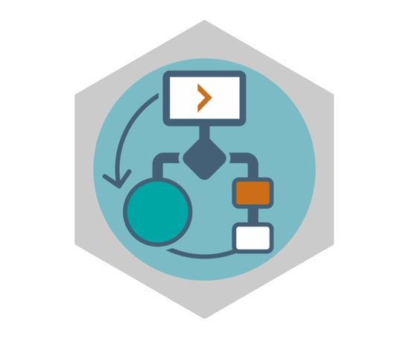

**10.1 Limitations**

* User cannot choose city for current use.
* User cannot customize theme on their profile page
* User cannot use coupons for current use

**10.2 System Enhancement**

* We will Provide all cities so that user can choose city.
* We will provide coupons service so that user can get extra discount.
* Add profile customize themes for user can view other user their profile attractive.

**11. References**



**11.1 References**

[**PHP Documentation**](https://www.flivv.com/php-web-development/)

[**Laravel Documentation**](https://www.mindline.co.in/Laravel)

[**MySQL Documentation**](https://www.javatpoint.com/mysql-features)

[**JavaScript Documentation**](https://procomcomputer.com.my/courses/22-javascript/)

[**HTML5 Documentation**](https://www.geeksforgeeks.org/html-introduction/)

[**CSS3 Documentation**](https://www.geeksforgeeks.org/css-introduction/)

[**jQuery Documentation**](https://www.geeksforgeeks.org/jquery-introduction/)

[**AJAX Documentation**](https://www.w3schools.com/php/php_ajax_intro.asp)

[**Laravel 8**](https://laravel.com/)

[**StackOverflow**](https://stackoverflow.com/)

[**Draw.io**](https://app.diagrams.net/)